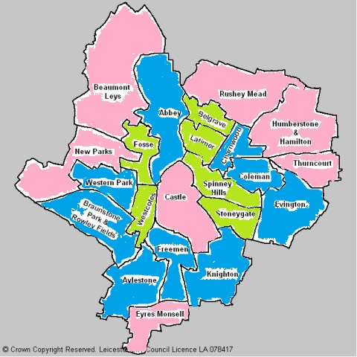

LESS THAN 50% OF PROPERTIES SOLID WALLS

APPROX. 50% OF PROPERTIES SOLID WALLS

Approx. 50% TO 100% SOLID WALL PROPERTIES