FREEDOM OF INFORMATION ACT 2000/ENVIRONMENTAL INFORMATION REGULATIONS 2004

Your request for information has now been considered and the Council’s response to your questions is shown below.

You asked:

- Please provide a copy of the document or documents submitted to the DHSC as outlined in condition 3 of the Market Sustainability and Improvement Fund 2024 to 2025 Guidance as per the below:
“Condition 3: As set out in the grant determination, the initial 2024 to 2025 report must be submitted by 11:59pm on 22 May 2024 and must include:

- confirmation that the local authority has allocated its share of the grant in full to adult social care, in line with condition 1
See below extracts from Leicester’s Market Sustainability and Improvement Fund submission for:
- MSIF Spend Return 2023 to 2024
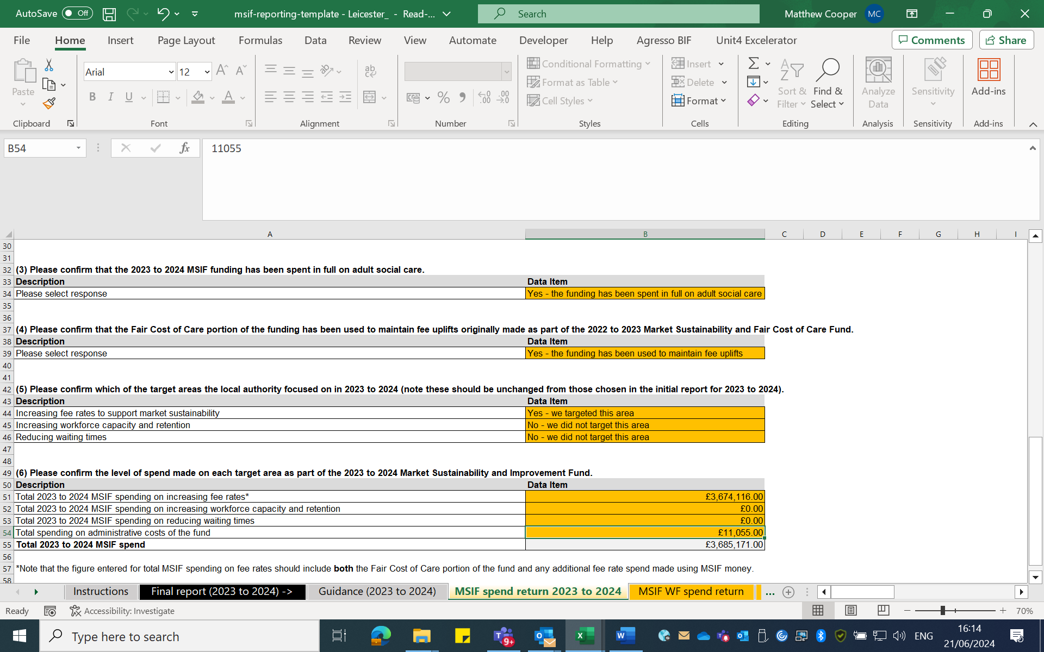
- MSIF Spend Return 2024 to 2025

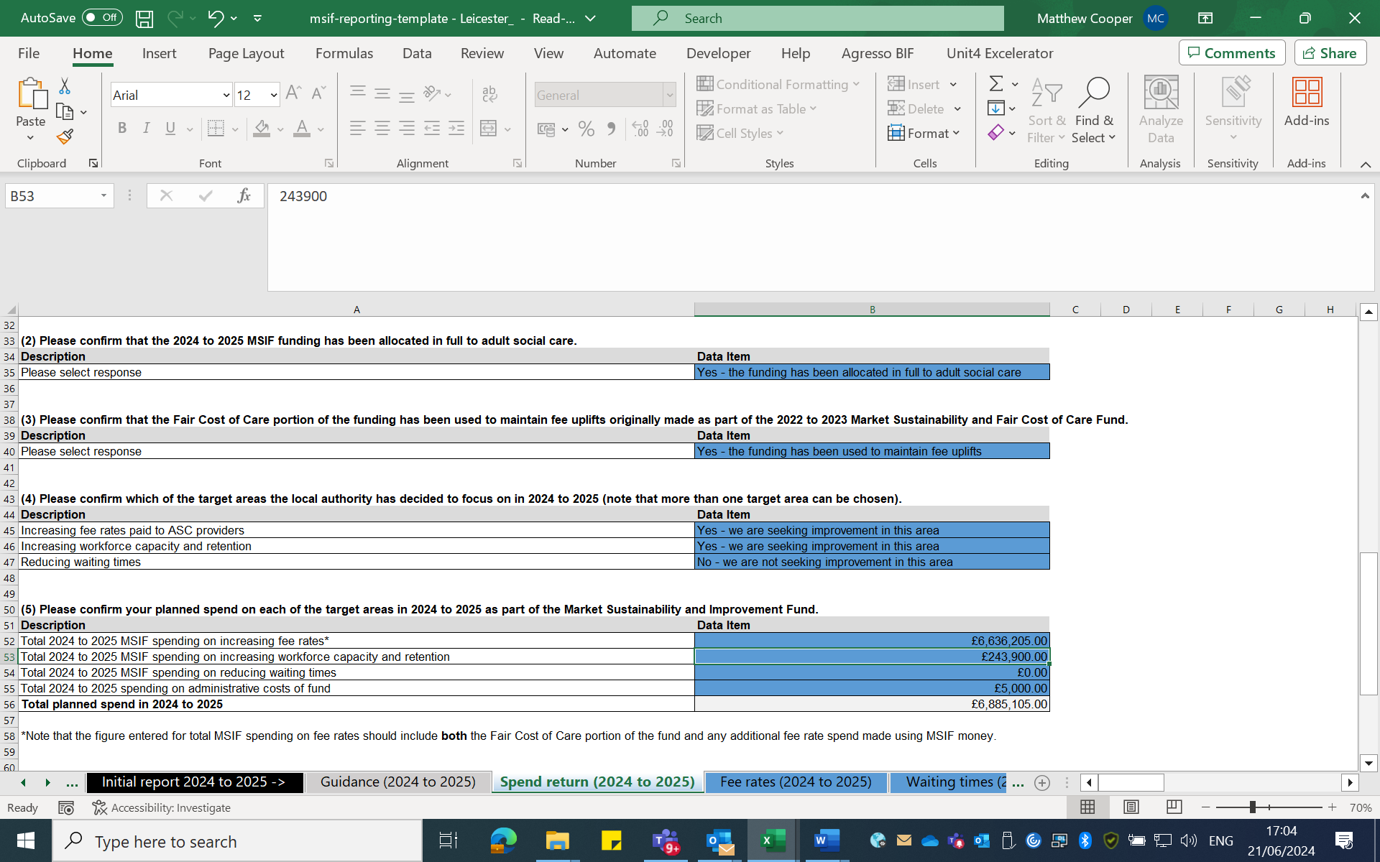

- confirmation that the local authority has used its share of the £162 million Fair Cost of Care component of the fund to maintain fee uplifts originally made as part of the 2022 to 2023 Market Sustainability and Fair Cost of Care Fund
See extract of MSIF Spend Returns for 2023 to 2024 (on page 1 of this response) and 2024 to 2025 (above).

- confirmation of which of the 3 target areas the local authority will seek further improvements in (local authorities must select at least one), alongside planned spend on each
See extract of MSIF Spend Returns for 2023 to 2024 (on page 1 of this response) and 2024 to 2025 (above).
- reporting against all the required metrics set out in the ‘Activities and metrics’ section of this guidance*

* The initial 2024 to 2025 report (May 2024) must include the following metrics:

- final average external provider local authority fee rate in 2023 to 2024 –
See extract of MSIF final average external provider local authority fee rate in 2023 to 2024 (below):

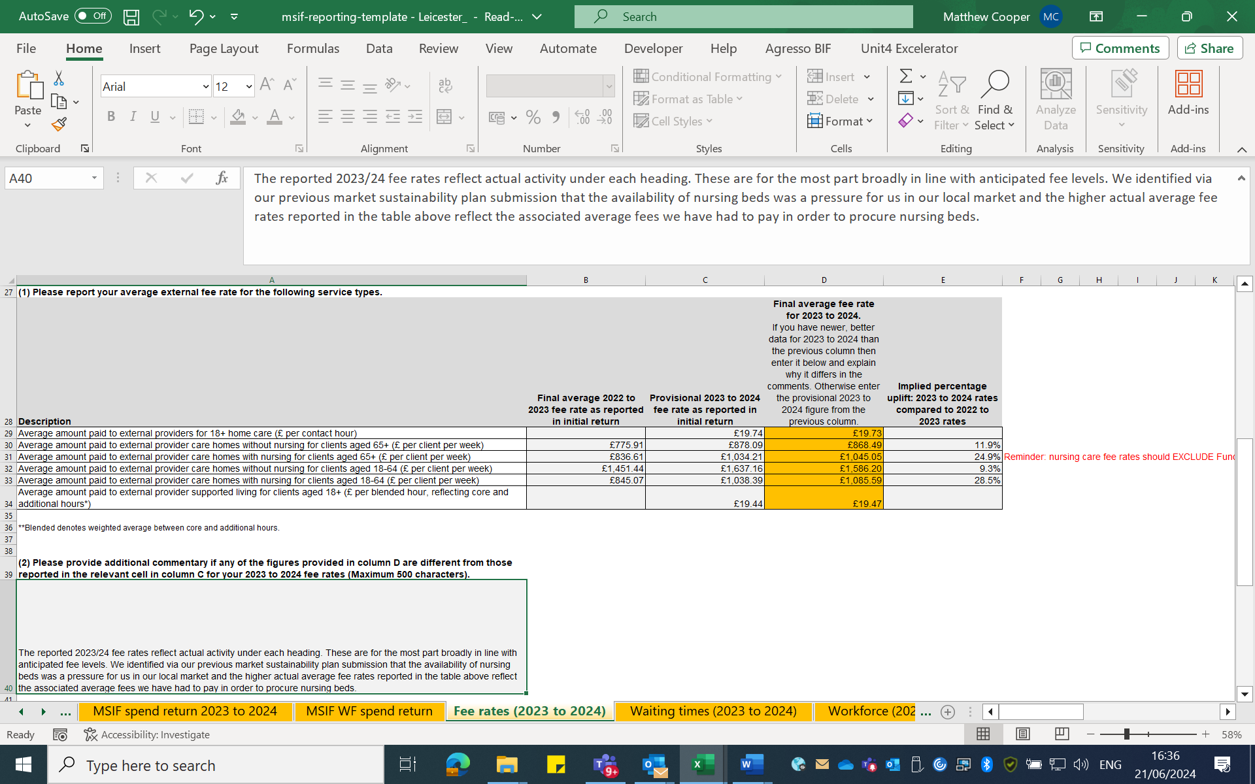

- average provisional external provider local authority fee rate in 2024 to 2025
See average provisional external provider local authority fee rate in 2024 to 2025 (below):

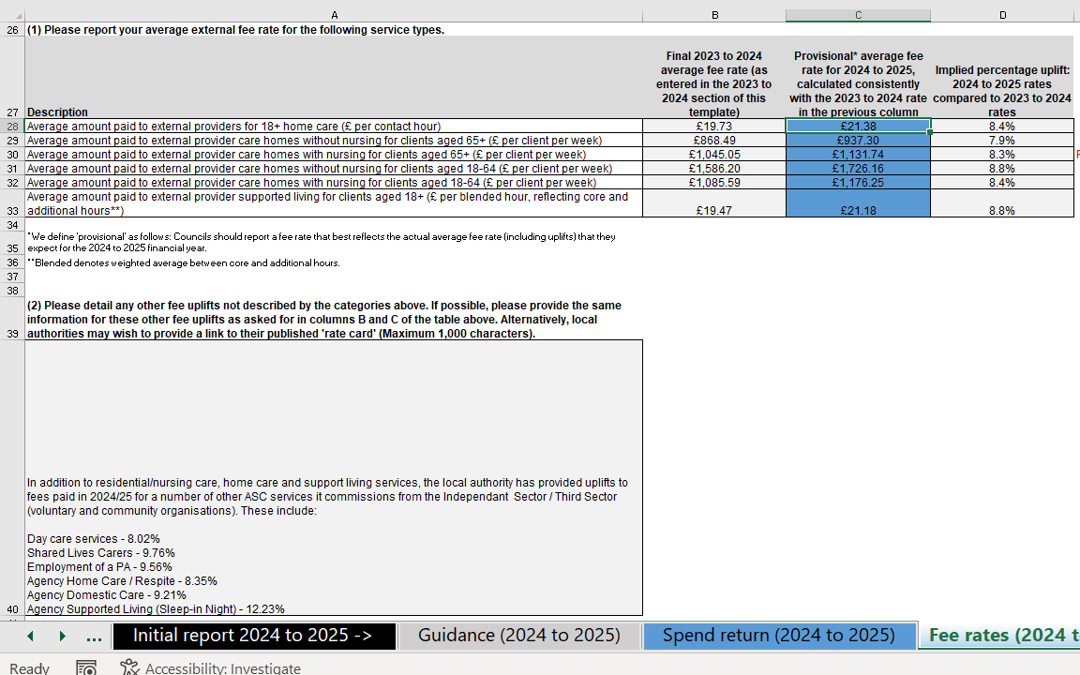

Free text to provide additional context on the report if required”
Included in above extracts where relevant.

You may re-use the information under an Open Government Licence.

If you are dissatisfied with the handling of your request, please write, explaining your grounds of appeal, to:

Internal Review
Information Governance & Risk
Email: info.requests@leicester.gov.uk

