Outcome Based Specification

Specification of Requirements for:
- Brief Summary of Service
  - The Council purchases journeys for children, young people and adult Service Users, as well as for Council staff using taxi Providers. These journeys are commonly planned e.g. trips to and from school or unplanned e.g. one-off journeys to an appointment. These taxi journeys supplement those provided by the Council’s fleet of in-house buses. The Council may at its discretion deliver the passenger transport needs of its Service Users through using either a bus and/or or a taxi.

  - Some Service Users using taxis require additional support or supervision which is provided through a passenger assistant, arranged by the taxi Provider. Some Service Users using taxis have additional needs of the vehicle e.g. the size of vehicle or ramps and wheelchair accessibility. Some Service Users need the Driver and/or passenger assistant to have specialist training e.g. how to help someone with a medical condition such as epilepsy.

  - This document sets out all the requirements for taxi provision and the expectations placed on all parties.

- Background and Context
  - The Council follows a pathway of options ranging from a personal budget for Service Users to make their own arrangements to the use of the Council’s own fleet vehicles where possible. Where all other options have been exhausted, the Council will consider use of taxi provision to assist with journeys.

  - The service area is demand-led and the volume of work may therefore increase or decrease over time. In 2018-19, approximately 200,000 journeys were commissioned via the taxi framework agreement.

  - Please also note that there is no guarantee of work once on the Agreement, and allocation of work will be determined via the call-off arrangements detailed in this specification in accordance with the Council’s needs arising from time to time.

- Strategic Aims and Priorities

Note: The Provider will not be responsible for reporting progress against the priorities and indicators below. The performance measures described in Section 8 below will be used as indicators of overall ‘direction of travel’, and as specific measures of service effectiveness.
  - The provision of taxis to support Service Users to access schools, day centres, attend contact appointments and to complete other essential or beneficial journeys supports a variety of priorities for the Social Care and Education Department.

  - The Provider will not be responsible for reporting progress against the aims and priorities below. The role of Providers to contribute towards these aims and priorities is recognised, and the quality of provision will be assessed via the Leicester City Council Contract Monitoring Framework (CMF), as set out in the Framework Agreement and in line with the penalty points included in this specification.

  - We are committed to supporting Service Users, including children, young people, vulnerable adults and families, and Council staff to be safe, be independent, be ambitious for themselves, and live the best life they can.
Social Care and Education – ‘Commitment and Purpose’ | 1. Keep people safe from harm  2. Promote inclusion and belonging  3. Enable people to be independent/self-sufficient and resilient  4. Enable people to pursue life opportunities  5. Support people’s rights  6. Support individuals’ self-improvement  7. Support people to have a safe place to live and thrive  8. Promote good emotional, mental and physical health
Strategic Commissioning Strategy | - Early intervention and prevention  - Commission services which enhance or increase Service User’s independence and focus on the most vulnerable  - Commission services that support carers to fulfil their role  - Support the development of a vibrant market providing a diverse range of quality services that meet local needs
- Specific aims and objectives of the service
4.1 To ensure that Service Users and Council staff are safely transported to and from planned pick up and drop off points, on time.

4.2 To ensure that taxi transport is as environmentally sustainable as possible, contributing to Council objectives to reduce emissions and improve air quality.

4.3 To ensure that services provided are of good quality, and benefit the physical, mental and emotional wellbeing of Service Users.

4.4 To ensure that the Council achieves good value for money from commissioned services
- Call-off arrangements
5.1 This section of the specification outlines the call-off arrangements that will determine how work will be allocated within the Agreement.

5.2 This section also refers to the operational allocation/acceptance/amendment/cancellation of journeys, linked to these arrangements.
5.3 The call-off arrangements to be used for this Agreement are outlined below. Providers may wish to refer to this throughout the life of the Agreement:
    - Stage One - Shared Journeys: Package allocated to Provider where minor changes to an existing journey could be made to safely transport another Service User;
    - Stage Two – Service User Choice: Where a shared journey (stage one) via a minor change cannot be achieved, the Service User (and/or their parent/carer) will be able to choose a Provider that is a) on the Agreement and b) able to deliver the journey at the advertised price and specification;
    - Stage Three – Ranking Based on Tender: Where a shared journey via a minor change (stage one) cannot be achieved, and where the Service User (and/or their parent/carer) does not express a choice of Provider (stage 2), a ranking will be used to allocate work based on the quality of Providers’ tender submission.
5.4 Below we outline what is meant by each stage of these call-off arrangements:
5.5 Stage One – (Shared Journeys)
5.5.1 Many of the journeys that Providers fulfil are shared, with more than one Service User sharing the same vehicle. For the benefit of these call-off arrangements, the Council will seek to establish where transport can be provided to a Service User utilising existing arrangements as a first call-off option.
5.5.2 Shared journeys will only be allocated where is it deemed safe and appropriate by the Council for a Service User to share transport, subject to a risk assessment being undertaken by the Council care management staff as part of service user needs assessment, and subject to the council being satisfied upon conducting regular review of such assessment that the shared journey arranged can continue
5.5.3 For the benefit of this Agreement, ‘minor changes’ refers to any journey assessed by the Council as eligible for a shared journey from a risk perspective, and that can be amended to fulfil a shared journey to a maximum of 50% increase/decrease in total cost of the journey, following the change to add/remove a service user.
  - Shared Journeys – Operational Matters
    - Where a taxi is needed, and an amendment to a journey can be made to accommodate additional Service Users, the Council will try to arrange for two or more Service Users to share a route. This will mean Service Users are picked up along the way. This will only be requested where it is safe for those Service Users to travel together, and where it does not significantly disrupt the journey of existing Service Users (to be managed on a case by case basis at assessment by the Council). This will be part of the assessment when a journey is first requested and will depend on the individual, their needs and risks, and risks will be continually reviewed by the Council and in line with feedback from service users, providers and any other source. Therefore, only the local authority can decide whether it is appropriate for more than one Service User to share a journey.
    - Where a shared journey is offered to a Provider, the Provider is expected to plan this route in the most efficient way possible, taking into account any risks identified by the Council. Please note that the Council reserves the right to determine a planned route for use if a Provider is to fulfil a shared journey.
    - Where new Service Users are added to a shared journey in accordance with the call-off arrangements, the Council will liaise with the provider to ensure that any risks are identified and mitigated. Where residual risks are considered to be too high in these circumstances, the Council reserves the right to amend/cancel the request for a shared journey and proceed with stages 2 or 3 of the call-off arrangements.
    - Any shared journeys will be kept under regular review by the Council in line with review/assessment of Service Users. Providers must share any concerns, changes or issues that arise relating to shared journeys, including parent/carer objections, with immediate effect.
    - Where a Service User is added/removed from the shared journey, the existing Request for Services issued to the Provider will be amended so as to confirm amendments to the call-off.
  - Stage Two – Service User Choice
    - Service User choice is an important principle of this programme, and where a shared journey cannot be achieved, Service Users will be asked if they have a preference of the Provider allocated to provide their support.
    - Where a Service User or their parent/carer indicates that they do indeed have a preferred Provider, the relevant Provider will be offered the package by the Council. The Provider will only be allocated the package however if they are able to meet the requirements of the Service User and at the cost determined in line with the Council’s payment schedule.
    - Only Framework Agreement Providers may be allocated via this process. If a Service User or their parent/carer requests to receive services from a Provider not included in the Agreement, they may be offered a Direct Payment by the Council in order to manage this themselves.
  - Stage Three– Ranking Based on Tender
    - The Tenders made by Providers at the time of establishing the Agreement will be ranked based on overall quality of responses. Where no other call-off arrangement can be made, the Council will issue an Order Form to all Agreement Providers inviting expressions of interest and then the package will then be offered to the highest-ranking Provider to have responded indicating a willingness to take on the package on the terms set out by the Council.
  - Journeys offered
    - The Council will categorise all requests for journeys in one of three statuses:
- ‘Emergency’ - Journeys required within a start date of 48 hours or less (including emergency Council journeys that may require a turnaround of less than 4 hours);
- ‘Urgent’ - Journeys required with a start date of between 48 hours and 5 Business Days; or
- ‘Standard’ - Journeys required with a start date of more than 5 business days.
    - Please note that where an amendment to a request is necessary, the Council will notify the Provider at the earliest opportunity (where possible with at least 48 hours’ notice).
    - Where a Provider suggests that they can partially meet the specified requirements, this will be considered by the Council. The Provider will make this clear to the Council during the process of package allocation.
    - Where a Provider has accepted a journey and has submitted the Provider Confirmation section of the Order Form, but then modifies or puts conditions to the terms of the proposed call-off, the Council may either re-issue the call-off or treat the Provider’s response as an inability to provide services and award the call-off to another Provider. This is outlined in section 9.3 of the Agreement.
    - The offers will be sent by electronic means to Providers in line with the call off methodology. This could be via email or through a portal or other IT system operated by the Council. The exact method of contact in use at the time will be communicated to all Providers in advance of use.
    - The Council reserves the right to change modes of contact liaising with Providers to other means and will ensure engagement with Providers prior to any changes other than in an emergency e.g. in the event of an IT system failure.
    - Work package offers to Providers will include full details of the required journey and will be communicated via the Order Form.
    - ‘Standard’ requests - If the request is a journey with a start date of more than 5 business days’ time, Providers will have 48 hours to respond to the offer, confirming either that the requirements can be fully met or partially met (with details of where changes would occur). No response will be taken to mean that Providers cannot fulfil the journey.
    - ‘Urgent’ requests - If the request is a journey with a start date of between 48 hours and 5 business days’ time, Providers will have 24 hours to respond to an offer, confirming either that the requirements can be fully met or partially met (with details of where changes would occur). No response will be taken to mean that Providers cannot fulfil the journey.
    - ‘Emergency’ requests - If the request is a journey with a start date of less than 48 hours from the time of referral/request, the PATS service will call Providers in tender rank order to ascertain whether they can accept the journey. The first Provider to accept the journey will receive the booking. Providers will be expected to provide a response on the same working day, and the Council will make a case-by-case judgement as to a reasonable time period for response.
    - Where delays in allocating a package for any reason occur that result in a ‘standard’ request becoming an ‘urgent’ request, or an ‘urgent request’ becoming an ‘emergency’ request, the higher risk level will be allocated (e.g. emergency takes precedence over urgent).
  - Acceptance of journey
    - At the end of the time period for responding, the Council will evaluate responses by the Provider/s as to how they can meet the requirements. The Council will then allocate work in accordance with the call-off procedure set out in this specification to award the journey to one or more Providers.
    - Providers who are allocated a journey will then be provided with full details of the journeys to be undertaken, including:
- full details of the to and from addresses
- commencement date of journeys and end date or date for review
- days the journey will be taking place
- Service User details and any specific adjustments required
- required specifications/fixtures/fittings of the vehicle
- whether a personal assistant is required or not
- any known risks or issues relating to the package for the Provider to be aware of
- commissioning cost centre (required for invoice recharging and service identification)
- quantity of Service Users, in accordance with call off arrangements
- details of any Service Users that will require a wheelchair
- pick-up/drop-off points
- any information relating to ‘meet and greet’ or ‘handover’ arrangements
- any other information that is relevant to the package
    - Providers will acknowledge any offers made to them by responding to the Order Form and confirm according to the ‘emergency’/’urgent’/’standard’ status, that the journeys will start on the planned date. If no acknowledgement is received, the package may be re-allocated to another Provider in accordance with the call off arrangements. The Order Form/response form/request for service will be used to confirm these arrangements.
    - Sub-Contracting – The Provider’s ability to sub-contract obligations under the Agreement will be subject to the provisions of Clause F1 of the Agreement. If a Provider is found to breach this they may face contractual action, including suspension and/or termination of Agreement. Please note: under no circumstances will PATS authorise any sub-contracting unless all staff/representatives of the Sub-Contractor have met all pre-commencement checks required by PATS to provide transport under this Agreement. A robust business case will also be required to justify why sub-contracting is required. Authorisation of any sub-contracting arrangements will be at the discretion of PATS. Drivers operating as a Sub-Contractor will be subject to the approval process as detailed in section 7.3 of this specification.
    - Providers should only accept packages that they believe are deliverable in line with specified requirements. Persistent handing back of packages is to be avoided in this Agreement and may lead to an investigation by the Council and potential allocation of penalty points to the Provider, and/or further contractual action, including suspension and/or termination of Agreement.
  - Journeys that cannot be allocated using the call-off arrangements
    - If all stages of the call-off arrangements are employed but no Provider is able to accept the package, the Council will telephone Agreement Providers in rank order to see what the reasons are for the journey being unfulfilled. The Council reserves the right to change requirements as part of these conversations with Providers where moveable barriers are identified. Any such case will be considered a new call-off request. The Council will make an agreement with the Provider over the telephone (followed up in writing) in these circumstances. An offer will be made for the journey to the first Provider that can offer a suitable service.
  - Unfulfilled journeys (journeys that are arranged but do not occur on any given day)
    - Where a one-off incident prevents a taxi Provider from fulfilling a journey and the journey cannot be provided by another employee that satisfies all conditions of the Agreement and the Request for Services, the Provider should notify the PATS service immediately.
    - Where the Provider confirms its inability to deliver the journey and an alternative pre-approved Driver cannot be found within the operator’s business, the council will decide to re-allocate the package in accordance with the Agreement or may decide to seek alternative provision e.g. the use of council fleet, friends or family of the Service User etc.

    - Where unfulfilled journeys occur, the Council will work with the Provider to understand the reasons for this and may investigate frequently unfulfilled journeys. The Council may issue penalty points in relation to unfulfilled journeys following an investigation.
    - Where a journey is unfulfilled because of circumstances beyond the control of the Provider e.g. unexpected closure of a school, absence of anyone at the home on collection etc. the PATS service must be informed immediately.
    - The Driver is required to stay at the destination address to ensure that the Service User/s are not left unattended. After 10 minutes, or immediately where it is clear that waiting will not resolve the issue, the Provider must contact the PATS team, who will telephone the listed contacts to enquire about next steps. If a Provider experiences extended wait periods, they are invited to make a business case for additional payment to cover any additional accrued costs. This business must be based on the standard taxi provider meter rate for waiting in excess of the prescribed 10-minute waiting period provided for in the Payment Schedule of the Agreement. Where extended waits are frequent, the Provider will refer to the Council so that amendments to the package can be considered (e.g. later pick up time).
    - In circumstances where no prior notice has been given, the Provider will be paid for the journey that was originally booked. An alternative journey may be required e.g. to take the child to emergency childcare. The Driver will be expected to fulfil this alternative journey as a one-off in exceptional circumstances. Where the new journey exceeds the distance of the original, planned journey, an additional payment will be made in line with the standard mileage costs on this Agreement (applicable to the additional distance only). Where the unfulfilled journey has an associated return or onward leg, PATS should provide instruction to the Provider as to next steps.
    - If a Provider is unable to fulfil a journey following alternative arrangements as a result of an emergency, they must notify the Council as soon as possible, in order to allow alternative arrangements to be made.
  - Late journeys
    - When a Provider becomes aware that they will be more than 10 minutes late in attending to a journey, they should notify the PATS team who will decide to either contact the Service User or family (and school where applicable) to advise them of the delay or to try to secure an alternative Provider to fulfil the journey.
    - Relevant parties (including parent/carers/school/Service User, Driver/passenger assistant) will be encouraged to notify the Council of any late journeys (more than 10 minutes). Any such case will be investigated by the Council, which may result in the issuing of penalty points to the Provider.
  - Amendments to journeys
    - If a change to a journey is required e.g. a new pick-up or drop off address or time for the journey, the following will apply:
    - For a change of less than 5 miles addition/reduction to journey or a change in time or other requirement, the existing Provider will be approached to see whether they can accommodate the change. Where this is possible, and the Provider is willing to accept the change, then the Council will issue a revised request for services. Where not possible, the Council will terminate the existing call-off arrangement and the journey will be re-allocated in accordance with the call off arrangements.

    - Where the adjustment is less than 1 mile, there will be no change to the price offered. Where the adjustment is more than 1 mile, the usual rates per mile will apply to the new journey (applicable to the additional distance).
    - For a change of more than five miles, the journey will be re-allocated in accordance with the call-off arrangements.
    - In the event of an otherwise regular journey not being required on any particular day (e.g. due to Service User circumstances), the Council will notify the Provider with as much notice as possible.
    - Providers must instruct Drivers and passenger assistants to contact them (the Provider) to request/discuss any changes to planned journeys. The Provider will then contact PATS to discuss and action this where agreed. Such amendments are not to be made independently of agreement with PATS under any circumstances.
  - Suspension of journeys
    - A journey may be suspended for a period of up to eight weeks by the Council. This allows for continuation of service once a period of absence has occurred (e.g. a holiday or time spent away from the usual home address etc). Periods of more than eight weeks will require the journey to be re-commissioned as per the call-off arrangements.
  - Cancellation of journeys
    - Where a Provider can no longer fulfil a planned journey on an on-going basis, the Council should be given at least one weeks’ notice of this cancellation. This allows for the journey to be re-allocated to another Provider in accordance with the call-off methodology. Where notice of less than one week is provided, the Council may issue penalty points for a late cancellation.
    - Cancellation of journeys will be monitored and, where they occur more than five times within a rolling 6-month period, may lead to the issuing of penalty points following an investigation by the Council.
    - Where the Council wishes to cancel a journey (e.g. the child moves away or leaves school), the Council will aim to provide at least five business days’ notice to the Provider, where this is possible. However, it is acknowledged that due to the nature of notification to the Council of reasons for cancellation, this period of notice may range from 24 hours to at least five business days. However, if the journey ceases with less than 24 hours’ notice, the Council will pay for the journey planned for the affected day, regardless of whether journeys are delivered or not. The Provider must inform the PATS team as soon as any Service User/parent/carer informs them of a wish to no longer be supported by the Provider. Failure to inform PATS of a cancellation of service may lead to the issuing of penalty points or further contractual action, including suspension and/or termination of Agreement, where required. Where the Council are unable to give at least five business days’ notice of this cancellation, the Council will provide as much notice as is possible.
- Vehicle Standards
  - In this section of the specification, we outline the vehicle requirements for all vehicles operating as part of this Agreement. This includes the technical and physical standards of the vehicle.

  - All vehicles

    - The Provider must ensure that all vehicles used to deliver work as part of the Agreement are licensed in all respects, and insured, equipped, and maintained in a thoroughly safe and roadworthy condition in accordance with Department of Transport regulations, manufacturers recommendations and the requirements policies of the Council.

    - The Council reserves the right to inspect the condition and compliance of any vehicle operating on the Agreement, as well as compliance with all licensing insurance and MOT documentation. This may involve both announced and unannounced inspections.

    - If any vehicle used in the delivery of services has a defect which could affect the safety of Service Users or other road users, the Provider must cease to use that vehicle on the Agreement immediately (or as directed in writing by the Council) until the defect has been rectified to the satisfaction of the Council, and at the Provider’s expense. In the event of this impacting on service delivery, the Provider will arrange for a suitable replacement vehicle that meets the requirements. If an alternative cannot be arranged by the Provider, the Council reserves the right to suspend/terminate the journey and contact other Agreement Providers to deliver the journey. The Council shall notify the authority licensing the vehicle or the Driver & Vehicle Standards Agency (DVSA) of any defects that are found, and following investigation may issue penalty points or take further contractual action, including suspension and/or termination of Agreement.

  - Condition of vehicles

    - All vehicles used as part of this Agreement must have a valid Motor Vehicle Test Certificate, up to date service record and comply with the testing standards of the licensing authority. This information must be provided to PATS prior to the commencement of any vehicle on this Agreement and may be requested at any time by the Council.

    - In addition, any vehicle being used on this Agreement must at all times be maintained in a fit and roadworthy condition, comply with all relevant legislative requirements, and conform to any other requirements specified in the Agreement.

    - Where a vehicle is deemed not to comply with Motor Vehicle Test Certificate, servicing, testing by licence issuing authority or Driver/Provider checks, the Provider is required to contact PATS immediately. Where the vehicle requires time off the road to make necessary changes, an alternative vehicle that is compliant with all standards set out in this specification and is of an equivalent standard should be arranged by the Provider. If this is not the case, the Council will re-allocate the package in accordance with call-off arrangements, as detailed in the Agreement.

    - All vehicles used to provide Services under this Agreement must be operated by a Driver with full UK Driving Licence and Driving Licence for Taxis and Private Hire Vehicles. Evidence of this will be required by the Council as part of the Driver pre-commencement checks and will form part of announced and unannounced, periodic, random checks undertaken as part of an Agreement management approach. These checks will be proportionate and not discriminate against any Provider. Additional checks will also be undertaken where the Council has intelligence to suggest there are serious failings of issues within a service. Where the Council has been advised of an issue relating to any work operated under the Agreement, additional checks may be carried out as required.

    - The exterior of the vehicle must be in good condition, with any damage to the vehicle reported by the Driver to the Provider immediately. The Provider should then notify PATS of any service disruption and planned action to address this.

    - The vehicle must be kept clean to a high standard inside and out.

    - To monitor both the interior and exterior of the vehicle, the Provider must ensure that all vehicles are checked daily, with data recorded on a Vehicle Checklist – an example of this is included as Appendix A.

    - The vehicle must have the capacity to maintain a reasonable internal temperature consistent with the needs of Service Users.

    - All vehicles operated as part of this Agreement must comply with any testing and quality assurance processes in line with their licence conditions.

  - Fixtures and fittings

    - All vehicles operating as part of this Agreement must be fitted with seat belts on all seats. It is the responsibility of the Driver to ensure that seat belts are worn by Service Users in accordance with all current legislation. Signage indicating the requirement to wear seat belts should also be clearly displayed. The Driver and Provider are responsible for checking and maintaining seatbelts and signage relating to seatbelts at all times. This may be checked by the Council at any time.

    - Any vehicle used to transport wheelchair users must be able to safely secure a wheelchair using a minimum of a three-point anchorage system (lap and diagonal).

    - Where appropriate, the Provider will be informed of required seatbelt extensions, harnesses, booster seats, child safety seats or appropriate child proof locking that they must provide to meet the requirements of a journey. Where the specification of a journey requires any/all of these adjustments, the Provider must ensure they are installed and used safely. No child, irrespective of age, is to be carried in the vehicle unless appropriate seating is available and correctly fitted and the Council’s assessment states that carrying is appropriate within the request for transport. The Provider will cover any costs relating to these requirements.

    - Each vehicle must have the required number of seats for the number of Service Users to sit in the back of the vehicle, including for passenger assistants; each Service User must have their own seat and must not be carried. The Council will not accept, for example, three Service Users sharing two seats or other variations of this.

    - All vehicles must be fitted with a basic First Aid Kit for minor incidents, equipped according to the NHS Basic First Aid Kit guidance: https://www.nhs.uk/common-health-questions/accidents-first-aid-and-treatments/what-should-i-keep-in-my-first-aid-kit/. The Driver and Provider are responsible for checking and replenishing the first aid kit as necessary to ensure that it is compliant with the above guidance at all times. This may be checked during any vehicle inspection.

    - All vehicles must be fitted with at least one fire extinguisher in an easily accessible position for the Driver. The Driver and Provider are responsible for checking and replenishing the fire extinguisher at all times. This may be audited as part of the Council’s Agreement management approach.

    - All vehicles must be equipped with communication devices such as radios, hands-free systems etc. that allow the Driver to contact the Provider, the Council and emergency services at all times. To clarify, use of a mobile phone as a communication device is permitted if it is securely fitted to the car and provides a hands-free function. The use of any communication devices is the responsibility of the Driver to ensure that they only transmit material suitable for Service Users. All installed communications equipment, including the use of such equipment, must comply with the Law.

  - Ramps and Tail-lifts

    - Any vehicle equipment must be installed, operated and maintained in accordance with the manufacturer’s instructions, and any lifts must be tested according to LOLER (Lifting Operations and Lifting Equipment Regulations 1998). The LOLER certificate must always be kept in the vehicle and produced for inspection if/when requested by the Council. The LOLER certificate may also be requested by the Council as part of any licensing requirements for vehicles licenced by the licensing authority.

    - Stowed ramps or lifts must not prevent service and emergency doors from being operated from inside and outside the vehicle. Internally stored lifts must fold down as designed to allow access to the emergency exit when the door is open.

    - Stowed ramps or lifts must not prevent service and emergency doors from being operated from inside and outside the vehicle. Internally stowed lifts must fold down as designed to allow access to the emergency exit when the door is open.

  - Substitution

    - When the Provider considers it necessary to replace or temporarily substitute a vehicle due to service requirements, fleet renewal etc., it must ensure that the replacement vehicle is compliant with this specification and with the vehicle requirements for the journey.

    - If as a result of this vehicle substitution the Provider cannot guarantee the above factors, they must contact PATS immediately. The Council will then determine if the proposed substitution is acceptable, or if the package needs to be re-allocated.

  - Larger vehicles with a capacity of nine or more passenger seats and additional vehicle requirements

    - All vehicles operated with a capacity of 9 or more passenger seats will have a bottom step a maximum of 250mm above the ground, at the rear of the vehicle and to other main exits.

    - In some circumstances, additional vehicles requirements may be necessary to address a specific need. Where this is the case, it will be included as part of the Order Form for the work. The Council may require the Provider to visit a Council depot (likely to be Sulgrave Road) and for the vehicle to be assessed by the Council to ensure it meets these bespoke requirements. If the vehicle does not meet these bespoke requirements, the Provider will not be able to deliver the support and the package may need to be re-allocated; this is at the discretion of the Council.

  - Audio, Visual and CCTV

6.8.1 Any audio, visual and CCTV data recorded and/or stored relating to this Agreement is subject to the conditions of the Data Protection Act 2018, including General Data Protection Regulation 2016 (GDPR) and account should be taken its use of guidance from the Information Commissioners Office (ICO) and the Surveillance Camera Commissioner (SCC). This applies in all cases and the Provider must ensure that they are compliant with all current legislation, in particular compliant with data subject rights and international transfers.

6.8.2 Providers must not record any audio, visual or CCTV data on any journey under this Agreement, without prior agreement in writing from the Council.

6.8.3 Where Providers have confirmed that their vehicles are fitted with audio, visual and/or CCTV recording capabilities, they should provide evidence to the Council of suitable assessments undertaken regarding its installation and use.

6.8.4 Where they have then been allocated a journey, any contracted Provider using CCTV systems in its vehicles must notify the Service User via clear signage in the vehicle that this equipment is fitted and in use.

6.8.5 Where CCTV systems are installed and use, they should only be activated at need and continuous recording of audio and visual CCTV should not be undertaken.

6.8.6 The installation, maintenance, storing and/or processing of audio, visual or CCTV systems, including associated data, will be at the expense and risk of the Provider.

6.8.7 The Council reserves the right to inspect the any audio, visual and CCTV data recorded and/or stored relating to this Agreement as part of Agreement management or in response to a complaint.

6.8.8 Where any audio, visual or CCTV data is approved for use on a journey and is then recorded and/or stored by the Provider, the Provider must not under any circumstances share this data with any parties other than the Council or where required by law.

  - Environmental Standards

    - The Authority is seeking to use its procurement powers to reduce emissions from its own vehicles and those of Providers working on behalf of the Authority.

    - In line with this approach the Authority also has an obligation under the EU Clean Vehicles Directive 2009 to use its purchasing power to promote the uptake of clean and energy efficient vehicles. When the public sector either buys or leases a vehicle, they must take into account energy consumption, CO₂ and pollutant emissions over the whole lifetime of the vehicle. The Clean Vehicle Directive is enacted in England, Wales and Northern Ireland by the Cleaner Road Transport Vehicles Regulations 2011. The Council’s Transport Strategy extends these obligations to large procured transport services (such as this Agreement). Hence, environmental standards as outlined below are key.

    - The Regulations state that any public sector contracting authority, entity or Provider when purchasing or leasing road transport vehicles must take into account the operational lifetime energy and environmental impacts, in respect of vehicles purchased or leased, including:

- energy fuel consumption;
- Carbon Dioxide emissions; and
- emissions of Nitrogen Oxides (NOₓ) and particulates.

    - All vehicles used in fulfilment of this Agreement shall conform to Euro 5 standard as a minimum unless exempt in accordance with section 6.9.5, as detailed alongside best practice guidance in the table below:

Vehicle Category | Minimum Requirements at go-live | Best Practice | Other considerations
Cars (incl. all taxis operating on this Agreement at the point of go-live) | CO₂ – 130g/km or less  emissions – Euro 5 or better (e.g. Euro 6 or zero emission) | CO₂ – 100g/km or less emissions – Euro 6  Or  CO₂ – 75/gkm or less emissions - Ultra-low emissions vehicle (ULEV) | Use of renewable fuels – e.g. bio fuels, renewable electricity,  Telematics to support fuel efficient driving.
In addition, all vehicles registered to provide support via the Agreement after 01/08/2020 must be Euro 6 compliant or better.

Any vehicle operating on the Agreement must be compliant with the emissions standards of Leicester City licensing, including vehicles licensed outside of Leicester.

    - Please note that the Council acknowledges that there is currently a shortfall of vehicles in Leicester that are wheelchair accessible and are at least Euro 5 compliant. Where such a vehicle is required but a Provider is unable to provide a vehicle that meets these requirements, Euro 4 compliant vehicles may be used on this Agreement. However, all attempts to use a vehicle at least Euro 5 compliant or better should be made by Providers, and the Provider must notify the Council of the substitution prior to accepting a package.

    - Where a Provider can facilitate a journey but only using a vehicle that does not meet the above standards, they must inform the Council prior to accepting a journey. The Council will then allocate work to a Provider in accordance with the call-off arrangements and reserves the right to refuse allocation to a Provider if they are unable to meet environmental standards.

    - Added Value – In line with the Council’s commitment to reducing emissions, we encourage Providers wherever possible to: exceed the minimum for euro standards, and/or use of alternative/low-emissions vehicles to reduce CO₂. Please note: a proportion of the quality score determined in our Method Statement will reward Providers who can demonstrate a commitment to reducing emissions.

    - The Council is keen to monitor mileage, fuel use and carbon emissions from travel under the Agreement – for those vehicles subject to Leicester licensing conditions, the Council will record this information as part of required vehicle testing. The Council reserves the right to use this information to inform priorities relating to Agreement management activity (e.g. evidence to inform spot checks).

- Driver and Passenger Assistant Standards
  - In this section of the Specification, we will address the core contractual requirements of both Drivers and Passenger Assistants in turn. This section also outlined requirements of Drivers and passenger assistants in managing operational issues; please also refer to Appendix M, which outlines our Code of Conduct for Drivers and Passenger Assistants.

  - Drivers

7.2.1 ‘Drivers’ within the context of this specification refers to the individual operating the vehicle being used to carry out work commissioned via the Agreement.

7.3 Pre-commencement checks

7.3.1 At least seven days prior to the commencement of a Driver on any journeys commissioned via this Agreement, the following Driver details will be provided to the Council:

a) Full name, address and date of birth of all Drivers;
b) DBS (to the Enhanced level) record for all Drivers – this must be valid within the last three years;
c) Training records in accordance with the terms sets out in this Specification for all Drivers wishing to operate within the Agreement (core required training is specified in this specification);
d) Complete driving licence with accompanying photo ID, complete driving license for taxis and private hire vehicles’; and
e) ID badge as issued by the relevant licensing authority, signed copy of the Driver Code of Conduct as outlined in Appendix M’.

7.3.2 All information to be submitted to the Council’s PATS team as a hard copy to: 37-39 Sulgrave Road, Leicester LE5 1NU or electronically to pat-ops@leicester.gov.uk (any changes to this procedure will be notified to Providers as soon as possible). All information submitted as part of this pre-commencement check must be the original document.

7.3.3 Providers are required to notify the Council of any Driver that leaves the service or is no longer involved in providing services as part of this Agreement.

7.3.4 An up to date record of Driver details will be supplied to the Council on a quarterly basis, to include:

a) First Name
b) Surname
c) Badge number
d) Vehicle Plate HCV/PHV
e) Insurance Expiry Date
f) Badge Expiry Date
g) DBS Expiry Date
h) DBS Start Date
i) DBS number
j) Training completed

7.3.5 In addition, the Provider will provide copies of National Insurance Numbers, Tax Identification Numbers or evidence of PAYE for any Driver employed in the operation of the Agreement, upon request by the Council.

7.3.6 Following the submission of pre-commencement information to the Council in accordance with the Specification, Drivers that have passed pre-commencement checks carried out by the Council on the Agreement will be allocated an ID badge by the licensing authority. This ID badge must be in date and be visible at all times. Under no circumstances are Drivers to share or exchange ID badges, or work on this contract without their ID badge. Failure to produce the ID badge allocated to the individual will result in the allocation of Penalty Points as detailed in section 16 and be considered as a breach of Agreement.

7.3.7 The Provider will cover the cost of all pre-commencement checks for all drivers.

7.3.8 Where a Driver has undertaken enhanced DBS clearance, but the Council has evidence to suggest that the individual should not support the Agreement, the Council reserves the right to deem that person unsuitable and will refuse clearance for use.

7.3.9 Drivers who hold a driving licence for taxis and private hire vehicles outside of the Leicester Council licensing area will not be excluded from this Agreement. However, Drivers must meet the same standards expected of Drivers licensed in Leicester. This includes compliance with this Specification and its appendices. This is to ensure all Drivers and passenger transport organisations are competing on an equal basis.

7.4 Training

7.4.1 All Drivers must have completed all mandatory training prior to them supporting any journeys via this Agreement and must undertake refresher training to keep this relevant. All Drivers must also complete any additional training that is set out in the Order Form as a requirement of a specific call-off request, prior to the commencement of the journey. Core requirements are outlined below:

a) First Aid
b) Positive Handling
c) Dealing with bodily fluids & spillages
d) Lifting training
e) NVQ 2 transporting children with SEN
f) Manual Handling
g) Certificate of Professional Competence
h) Child Protection
i) Safeguarding
j) Passenger & Transport Awareness Training
k) Child Seat Training
l) Managing challenging behaviour
m) Banksman training
n) Contact Training (if required on Order Form)
o) Minibus Driver Awareness Scheme (if required on Order Form)

7.4.2 Additional training needs will be specified by the Council at the point of referral.

7.4.3 Compliance with training requirements is the responsibility of the Provider. The training outlined above is mandatory where the Driver interacts with the relevant vulnerable groups (i.e. children’s specific training is mandatory only to those Drivers supporting children as part of the Agreement).

7.4.4 Any costs incurred as a result of training will be incurred by the Provider, unless otherwise specified by the Council.

7.5 Allocation of Drivers

7.5.1 The Provider will allocate a Driver that is equipped to provide the commissioned journey in compliance with this Specification.

7.5.2 In some cases, the Council may specify particular requests as part of the allocation of a Driver. This will be communicated clearly at the point of offering the package to a Provider, at which point the Provider can make a judgement as to whether they can meet these needs. The Provider must ensure that any specific requests can be met at the point of response to the Order Form, and that these requirements are indeed met for journeys they are commissioned to provide.

7.5.3 In some cases, it may also be deemed necessary for the Driver to meet with the relevant officer of a school/social services establishment/parent or carer in order to be briefed on particular needs of a Service User. This will be arranged between the stakeholder group and the Provider. The Provider must ensure that any reasonable requests are met for journeys they are commissioned to provide.

7.5.4 Drivers must be able to communicate in verbal and written English to a standard as to not adversely impact the operation of the service. No person other than the named Driver allocated to a commissioned journey may act as a Driver on the Agreement, except in an emergency, when another Driver already approved by the Council may be substituted. Where a new named Driver is allocated to a journey, the Council must be advised in advance of the change.

7.5.5 The Council must be notified in advance of any Driver substitution with clear reasoning for the substitution, with 24 hours’ notice or immediately as the needs are identified. If the Council is not satisfied with the reasoning or evidence to support a substitution, the Council reserves the right to refuse this request, cancel the call-off and provide alternative transport using internal transport options or via the call off arrangements.

7.5.6 Any person acting as a Driver must provide their name and address, and Council issued identification badge, passport or DVLA photo card driving licence to establish his/her identity to any officer of the Authority on request.

7.6 Payment/Remuneration of Drivers

7.6.1 It is the legal responsibility of Providers to operate in line with all relevant employment legislation.

7.6.2 The payment schedule within the Framework Agreement sets out the rates the Council will use to calculate rates of payment to Providers.

7.6.3 The Council will only pay for aspects of the journey that are agreed between the Provider and the Council on allocation. For example, the Provider allocated at a price that includes a standard taxi, but on the day is only able to provide a more specialist vehicle than requested due to availability, the Provider will be expected to bear any additional costs.

7.7 Safeguarding

7.7.1 Where an incident has been reported regarding the conduct of a Driver, the Council reserves the right to suspend the Driver’s engagement on any journey commissioned via this Agreement for the duration of the investigation.

7.7.2 Where a Provider becomes aware of something which brings into question the Driver’s suitability to work with Service Users, the Provider must notify the Council in line with the Council’s Safeguarding Policies, as per the Agreement.

7.7.3 Where the status of a Driver’s driving licence changes for any reason, including issuance of driving penalty offences, the Provider must notify the Council immediately. If the Council advises that this change elevates risk of the Driver operating on the Agreement, the Council will notify the Provider to immediately suspend the Driver from working on any journey under the Agreement. The Council will also notify the Licencing Authority who may take other action relevant to their licensing conditions.

7.7.4 Where a Driver is aware of a potential safeguarding incident, they are required to notify the Council in line with the Council’s Safeguarding Policies, as per the Agreement.

7.8 Passenger Assistants

7.8.1 ‘Passenger Assistants’ within the context of this specification refers to the individual/s employed in a support capacity in line with assessed Service User needs.

7.9 Pre-commencement checks

7.9.1 At least seven days prior to the commencement of a Passenger Assistant on any journeys commissioned via this Agreement, the following details will be provided to the Council:

a) Full name, address and date of birth of all Passenger Assistants;
b) DBS (to the Enhanced level 4 or ISA equivalent) record for all Passenger Assistants – this must be valid within the last three years;
c) Complete training records in accordance with the terms sets out in this Specification for all Passenger Assistants (core required training is specified in this specification);
d) ID badge as issued by the relevant licencing authority, signed copy of the Passenger Assistant Code of Conduct as outlined in Appendix M;
e) An up-to-date record of Passenger Assistant details will be supplied to the Council on a quarterly basis, to include:

a) First Name
b) Surname
c) Badge Number
d) Badge Expiry Date
e) DBS Expiry Date
f) DBS Start Date
g) DBS Number
h) Training Completed.

7.10 In addition, the Provider will provide copies of National Insurance Numbers, Tax Identification Numbers or evidence of PAYE for any Passenger Assistant employed in the operation of the Agreement, upon request by the Council.

7.10.1 All information to be submitted to the Council’s PATS team as a hard copy to: 37-39 Sulgrave Road, Leicester LE5 1NU or electronically via pat-ops@leicester.gov.uk (any changes to this procedure will be notified to providers as soon as possible).

7.10.2 Providers are also required to notify the Council of any Passenger Assistants that leave the service.

7.10.3 An up to date record of all Passenger Assistant details will be supplied to the Council on a quarterly basis. In addition, the Provider will provide copies of National Insurance Numbers, Tax Identification Numbers or evidence of PAYE for any Driver employed in the operation of the Agreement, upon request by the Council.

7.10.4 Following submission of relevant information to the Council, that are cleared to work on the Agreement will be allocated an ID badge by the Licencing Authority. This ID badge must always be in date and be visible. Under no circumstances are Passenger Assistants to share or exchange ID badges Failure to produce the ID badge allocated to the individual will result in the allocation of Penalty Points to the Provider.

7.10.5 The Provider will cover the cost of all pre-commencement checks for staff.

7.10.6 Where a Passenger Assistant has undertaken enhanced DBS clearance, but the Council is not satisfied that the Passenger Assistant is a ‘fit and proper person’ to carry out employment as a Passenger Assistant, the Council reserves the right to deem that person unsuitable and refuse clearance.

7.11 Training of Passenger Assistants

7.11.1 All Passenger Assistants must have completed all mandatory training prior to them supporting any journeys via this Agreement and must undertake refresher training to keep this relevant. All Passenger Assistants must also complete any additional training that is set out in the Order Form as a requirement of a specific call-off request, prior to the commencement of the journey. Core requirements are outlined below:

a) Passenger and Transport Services (PATS)
b) First Aid
c) Positive Handling
d) Dealing with bodily fluids & spillages
e) Lifting training
f) NVQ2 transporting children with SEN’s
g) Manual Handling
h) Child Protection
i) Safeguarding
j) Passenger & Transport Awareness Training
k) Child Seat Training
l) Contact Training
m) Medication management
n) Managing challenging behaviour

7.11.2 Please note that whilst some training is mandatory for all Passenger Assistants, additional training may be required based on Service User needs. Additional training needs will be specified by the Council when a package is allocated or when assessed needs change, and Providers must ensure that staff are complaint these requirements when accepting a package.

7.11.3 Compliance with training requirements is the responsibility of the Provider.

7.12 Allocation of Passenger Assistants

7.12.1 Leicester City Council staff will determine if a Passenger Assistant is required when assessing the needs of an individual. If a Passenger Assistant is required, the Provider will be notified of this when the Council allocate a journey or following a Service User review.

7.12.2 The Provider will, following formal request by the City Council, allocate a Passenger Assistant to a journey in compliance with this Specification. Under no circumstances should a Passenger Assistant be used for a journey without the prior agreement of the Council. Under no circumstances should a journey take place without a Passenger Assistant if one has been requested by the Council.

7.12.3 If a Provider feels that a journey they are delivering requires a Passenger Assistant, but this is contrary to the Council’s assessment, they are invited to contact the Council to notify them of their concerns at the earliest opportunity. The Council will then consider if a review is required based on this feedback.

7.12.4 In some cases, the Council may specify requests as part of the allocation of a Passenger Assistant, for example a male/female. The Provider must ensure that any specific requests are met for journeys they are commissioned to provide. Failure to provide any specific requirements where the Provider has confirmed they would meet in the Response to the Order Form, the Council will, if the changes present a risk to the Service User, re-allocate work as a new call-off request.

7.12.5 In some cases, it may also be deemed necessary for the Passenger Assistant to meet with the relevant officer of a school/social services establishment/parent or carer to be briefed on needs of a Service User. This will be arranged between the Council and the Provider, with individual requirements and timescales being negotiated on a case by case basis. The Provider must ensure that any requests are met for journeys they are commissioned to provide, and that they will advise the Council immediately if they are unable to meet any such requests. Inability to meet any requests following call-off may require the Council to re-allocate the package.

7.12.6 Passenger assistants must be able to communicate in verbal and written English to a standard as to not adversely impact the operation of the service. No person other than the named Passenger Assistant allocated to a commissioned journey may act as Passenger Assistant on the Agreement, except in an emergency, when another Passenger Assistant already approved by the Authorised Officer may be substituted. The Authority must be notified in advance of any passenger assistant substitution with clear reasoning for the substitution. If the Authority is not satisfied with the reasoning or evidence to support a substitution, the Authority reserves the right to refuse this request and provide alternative transport.

7.12.7 Any person acting as a Passenger Assistant must provide their name and address, and Authority issued identification badge, passport or DVLA photocard driving licence to establish his/her identity to any officer of the Authority on request.

7.13 Payment/Remuneration of Passenger Assistants

7.13.1 The pricing mechanism (as per the terms of the Framework Agreement) includes provision of payment to Passenger Assistants at the National Living Wage rate; this is included within the Council’s calculated taxi rates. It is the legal responsibility of Providers to ensure that all Passenger Assistants are remunerated at a minimum rate of the National Living Wage.

7.13.2 The Council will only pay for any Passenger Assistants that are allocated to a journey as a result of a formal request from the Council.

7.14 Safeguarding

7.14.1 Where an incident has been reported regarding the conduct of a Passenger Assistant, the Council reserves the right to suspend the Passenger Assistant’s engagement on any journey commissioned via this Agreement for the duration of the investigation.

7.14.2 Where a Provider is aware of any allegations or activity that may affect the conditions of a Passenger Assistant’s ability to work with vulnerable Service Users, the Provider must notify the Council in line with the Council’s Safeguarding Policies, as per the Agreement.

7.14.3 Where a Passenger Assistant is aware of a potential safeguarding incident, they are required to notify the Council in line with the Council’s Safeguarding Policies, as per the Agreement.

7.14.4 All Passenger Assistants are required to complete safeguarding training in line with all legislation and the Council Safeguarding Policies, as per the Agreement.

7.14.5 Passenger Assistants must travel in the rear of the vehicle with the Service Users to whom they are providing support and supervision, unless prior written agreement of the Council has been given for a different arrangement.

7.14.6 Where a Passenger Assistant is aware of regular lateness in journey times, they will notify the PATS team so that an assessment of the route can be made.
- Preparing for the Journey
8.1. Vehicle checks: It is the Driver’s responsibility to check that the vehicle is safe and ready for work at the start of the day. This check must be recorded on a vehicle checklist (Appendix A) and any problems need to be reported to the supervisor or manager before embarking. Any issues will be recorded on the vehicle checklist (Appendix A) also.

8.2 Appropriate restraints and clamping equipment: It is the Driver’s responsibility to ensure the correct amount, and type of wheelchair restraints, occupant restraints and other specialised seating is on board for the day’s journey requirements.

8.3 Restraint Checks: It is the Driver’s responsibility to ensure restraints are checked for damage or faulty operation, and any malfunctioning equipment is not used and returned to the office for examination or replacement immediately and recorded on the vehicle checklist (Appendix A). Restraints must be suitable and fit for purpose at all times.

8.4 Route folder: This folder is designed to share information between the office and passenger assistant and Driver. The folder should contain the following:

a) Appendix A - Vehicle Checklist (for Drivers/Providers)
b) Appendix B – Run Sheet template
c) Appendix C – Seating Plan template
d) Appendix D – Example Transport Management Plan (TMP)
e) Appendix E – Service User Amendment Form
f) Appendix F – Journey Incident Form
g) Appendix G – Behaviour Incident Form
h) Appendix H – Concern/Incident Form
i) Appendix I – Medical Incident Form
j) Appendix J – Motor Vehicle Claim Form
k) Appendix K – Accident Checklist Form

8.5 It is the Driver’s responsibility to ensure that the pack is in the vehicle prior to leaving the depot.

8.6 Fire Extinguisher, Spillage Kit & First Aid box: It is the Driver’s responsibility to check that the vehicle has the equipment as mentioned above, that it meets all requirements as set out in this specification, prior to setting out on the any journey and record any expired/faulty equipment on the vehicle checklist (Appendix A).

8.7 Seating plans: A seating plan is a map of the vehicle on which the Passenger Assistant describes where s/he has decided each Service User should sit. The decision on this journey should be based the following factors:

a) Vulnerability of the Service Users
b) Aggression/behaviour of the Service Users
c) Relationship with other Service Users
d) Maximum access to Service Users by Passenger Assistant
e) Updates following any previous incidents
f) Protection at all times of the Driver
g) The Service Users’ Transport Management Plan
h) Specialist requirements/adjustments for Service Users

8.8 The seating plan once decided upon should be adhered to on all subsequent occasions when Service Users are being transported and displayed within the vehicle. This gives the Service User a clear indication of what is expected of them.

8.9 It is the responsibility of the Passenger Assistant (or Driver if no Passenger Assistant is commissioned to support the journey) for each route to have an available and up-to-date seating plan. When a Passenger Assistant commences a run or has a new Service User accepted onto that journey, they should complete or amend the seating plan. A draft seating plan template is included as Appendix C.

8.10 Route & Run sheet: the planning of individual routes and the sequencing of the collection and return of Service Users shall be the responsibility of the Provider. Providers should be aware that the Council operates a policy that no Service User should travel for more than one hour for a single journey on Council transport, and routes are planned to comply with this requirement. Providers should always meet this policy and plan and schedule routes accordingly. Furthermore, the Provider should ensure that any circumstances that may compromise the Council’s maximum travelling time policy are reported immediately to PATS. A draft run sheet is included as Appendix B.

8.11 The Provider shall operate a separate vehicle for each individual route, except where agreed otherwise with PATS. Under no circumstances should Providers or Drivers offer Shared Journeys (carrying two or more Service Users in one vehicle) without prior agreement from the Council.
8.12 The Provider shall ensure that Service Users are taken directly to the intended destination and under no circumstances must the Provider deviate from the specified service or undertake other work whilst engaged upon a Council Agreement except with the permission of PATS.

8.13 Passenger Assistants (or Driver if no Passenger Assistant is commissioned to support the journey) must familiarise themselves with the parents and carers of any new Service Users and ask them if there is anything else they need to know. Any information new to the Passenger Assistant must be passed back to PATS by completing a Service User Amendment Form (Appendix E).

8.14 Understanding the individual needs of Service Users: It is both the Passenger Assistant’s and Driver’s responsibility to be aware of and adhere to the individual care requirements of each Service User en route. The Provider will be provided with information before a new Service User starts their transport. This information may be updated through periodic reviews of the Service User’s needs.

8.15 If through working knowledge of the Service User or talking to parents, carers or school and day centre staff the needs of the Service User change you must complete a Service User amendment form (Appendix E).

8.16 The Council reserves the right to audit any/all of this documentation/vehicle check records as part of ongoing Agreement management via the Leicester City Council Contract Monitoring Framework (CMF), as set out in the Framework Agreement.

- Operational Matters (Drivers and Passenger Assistants)
9.1 This section of the Specification outlines some of the key operational matters and considerations for staff supporting the Agreement. It relates to circumstances and processes.

9.2 Maintaining and promoting independence – Wherever possible, Drivers and Passenger Assistants should encourage Service Users to be independent. For example, carrying their own bags or fastening their own seat belt.

9.3 Customer Service - Drivers and Passenger Assistants are expected to be polite, courteous and helpful to members of the public, Service Users, parents/carers, school and centre staff at all times. From time to time it will be necessary to discuss matters and take advice from parents, school and day centre staff. If at any time a Driver or Passenger Assistant is asked to do something they shouldn’t do, or to do something not as instructed, they should explain their responsibilities in a calm manner or speak to a supervisor to seek clarification.

9.4 Drivers and Passenger Assistants will meet and greet Service Users to welcome them on each journey.

9.5 Drivers and Passenger Assistants must not take any instructions from any individual unless this is agreed with the Council.

9.6 Drivers and Passenger Assistants must not be under the influence of drugs or alcohol at any time during any journey commissioned under the Agreement. Drivers or Passenger Assistants suspected to be under the influence of drugs or alcohol will face immediate suspension from the Agreement to allow for investigation. Providers are expected in these circumstances to suspend the Driver from all driving activity pending investigation.

9.7 Timeliness: Our Service Users expect Providers to deliver safe, reliable and timely services. If the vehicle is likely to be 10 minutes or more late for a pick-up, the Driver must contact their Provider and communicate how late they are and the reason for the lateness. The Provider will then contact PATS to explain the reason for the issue and with a proposed solution. PATS will then raise with the parent/carer/school/day centre etc. Repeated lateness may result in an investigation by the Authority and may result in the issuance of penalty points.

9.8 Assisting Service Users to and from the vehicle: Where appropriate and safe to do so, Drivers and Passenger Assistants will support Service Users with equipment (e.g. walking frame, wheelchair) to access/leave the vehicle safely. This should be done in accordance with training requirements outlined in the Specification.

9.9 Until the Service User is transported to the agreed destination and is received by an appropriate individual (parent/carer/authorised individual known to the Council), the care for that Service User is the responsibility of the Driver and Passenger Assistant; this may involve escorting a Service User from the vehicle to their destination or helping a Service User to cross the road.

9.10 Unexpected Changes: Drivers and Passenger Assistants will notify the Provider about any unexpected changes to the package, such as a Service User having new equipment, prior to the journey taking place. The Provider must notify PATS immediately. This will enable a risk assessment to be carried out.

9.11 Incomplete journeys: In the event of a Service User not being picked up due to the Provider or Driver having a problem regarding an unsafe pick-up, be it uneven ground, difficult/dangerous steps to negotiate or a Service User with mobility difficulties etc. the Provider must inform PATS as soon as possible so a risk assessment can be undertaken and any changes to the pick-up as deemed necessary will be implemented. Where PATS agrees the pick-up would have been unsafe the agreed payment will be made.

9.12 In the event of a Service User declining to travel for whatever reason the Provider:

a) Must not force or argue with the Service User;
b) Must immediately contact PATS for advice and to ensure other parties involved are contacted in the event of a non-pickup.

9.13 In the event of a Service User absconding from a vehicle, the Driver or Passenger Assistant must notify the Council immediately, providing all information reasonably required by or on behalf of the Council including but not limited to: exact time and location that they were last seen, a description of clothing, behavioural concerns etc. The Provider should also, if appropriate, notify the Police immediately if they feel the Service User represents a danger to themselves or others.

9.14 Risk assessments: All Providers must ensure that the Drivers and Passenger Assistants are issued with the latest versions of Transport Management Plan (TMP, Appendix D) relating to each Service User that they transport.

9.15 Drivers and Passenger Assistants must ensure that they receive, read and fully understand the Risk Assessment documents relating to each Service User that they transport. Drivers and Passenger Assistants must be able to refer to the Risk Assessment documentation during the operation of the service as and when required and produce the Risk Assessment documentation immediately if requested by representatives of the Council.

9.16 Smoking, including e-cigarettes, is strictly prohibited at any time during the operation of any journey under the Agreement including any waiting period at the appropriate establishments.

9.17 Verbal or Physical Abuse from Service Users/members of the public: Where Drivers or Passenger Assistants are subject to verbal or physical abuse, they must maintain their professionalism and approach the situation in a calm way. De-escalation and protection of staff and other Service Users must be the priority. The Provider must notify the Council of any verbal or physical abuse within 24 hours.

9.18 Physical Intervention: In some circumstances, Drivers and Passenger Assistants have access to positive handling techniques to help them deal with potential or actual aggressive or physically harmful situations. Such techniques can only be used by staff that have undertaken appropriate training and may only employ such techniques as they have been specifically trained in and that are suitable for a particular Service User. Where positive handling techniques are used, the facts must be fully recorded and logged on every occasion and reported to PATS at the first opportunity. Failure to do this may result in contractual action, including suspension and/or termination of Agreement.

9.19 Where a Driver or Passenger Assistant comes across an incident or emergency, they must complete an Incident Reporting form (Appendix H) on every occasion and as soon as reasonably possibly. This form must then be submitted to PATS.

9.20 Other people in the vehicle: No unauthorised passengers are to be carried. The unauthorised transfer of Service Users could result in the call-off being suspended/terminated, and/or further contractual action, including suspension and/or termination of Agreement.

9.21 If it is indicated that a Service User must travel alone, this must be strictly adhered to.

9.22 Parent/Carer failing to meet a Service User: All Service Users must be delivered to a designated responsible adult or be seen to safely access their own homes. If upon arrival the responsible adult is unavailable, the following procedure should be followed by Drivers and Passenger Assistants:

a) Passenger Assistant (or Driver if no Passenger Assistant is commissioned to support the journey) to contact the PATS team to determine if an alternative arrangement is in place or can be arranged.
b) Driver to continue with the route, dropping any remaining Service User’s home. On completing the route, return for a second attempt at drop-off.
c) Should no one be available at this time then, the Passenger Assistant (or Driver if no Passenger Assistant is commissioned to support the journey) must contact the PATS team again to advise. An alternative address should have been arranged by this time

9.23 Safeguarding/Child Protection Issues: Children or Adults who report to a Driver or Passenger Assistant that they have been abused or are concerned about their welfare must be listened to and heard whatever form their attempts to communicate their worries take. Any concerns should then be shared with the Council in line with the Council’s Safeguarding Policies, as per the Agreement.

9.24 The Driver and Passenger Assistant should always adhere to the Service User’s Transport Management Plan (TMP). A draft TMP is included for reference as Appendix D.

9.25 It is important to listen to the Service User and avoid interviewing, asking questions or interrupting the Service User. It is not appropriate to make suggestions as to alternative explanations for their worries.

9.26 All information should be noted carefully, including timing, setting, who was present and what was said in the Service User’s own words. This record should be signed and dated by the person who listened to the Service User.

9.27 The written report of the disclosure should be given to PATS within 24 hours of the disclosure, who may then at their discretion share with relevant parties. For children, this may involve the school head teacher and Child Protection Officer, and for Adults may include the allocated worker and/or safeguarding adults team.

9.28 Drivers and Passenger Assistants must not promise confidentiality to a Service User that makes an allegation. Providers must ensure that their staff explain that they will need to share the information to ensure the Service User’s child’s safety but only people who need to know.

9.29 Complaints: Complaints will be made to PATS relating to journeys delivered via the Agreement. PATS will then liaise with the complainant, Provider and other stakeholders as required to progress this. In the event however that the Provider receives a complaint relating to a journey delivered via the Agreement, the Provider should notify PATS within 24 hours and pass on details of the complainant. The Provider must cooperate with the Council in relation to its investigation of any compliant and that the Provider shall provide all data, information, record, co-operation and assistance reasonably required by the Council in dealing with any complaint and within timescales reasonably prescribed by the Council.

9.30 Medical Emergencies: In the event of a medical emergency, the Passenger Assistant (or Driver if there is no Passenger Assistant commissioned to the journey), will be responsible for managing this situation within the parameters of their training and provide any further information reasonably requested by the Council. However, if there are other Service Users on board, the Driver will share responsibility for managing these Service Users, sharing information about these Service Users with their Provider and with PATS so that appropriate arrangements and communications can be put in place. In the event of an emergency that is beyond the training of the Passenger Assistant and Driver, a call to the emergency services (999) should be made immediately.

9.31 Spilt Bodily Fluids: Passenger Assistants (or Driver if there is no Passenger Assistant commissioned on the journey) will be responsible for dealing with any spilt bodily fluids in the vehicle. However, once back at the depot the vehicle may need further decontamination and any soiled PPE equipment will need disposing of and replenishment. This is the responsibility of the Driver and Provider.

9.32 Transporting of medication: Passenger Assistants (or Driver if there is no Passenger Assistant commissioned to the journey) will not normally administer medicines and must not do without agreement from PATS and the parent/carer, and before they have received necessary training to fully understand what procedures and protocols to follow.

9.33 From time to time, the Passenger Assistant or Driver may be asked to pass messages, medication equipment between home and the appropriate establishment(s). In such circumstances, the medication or message (if appropriate) should be clearly labelled with the Service User’s name, address and date of birth, and carried in a sealed envelope or container in the Service User’s bag. Equipment should be stored safely and securely on the vehicle during each journey.

9.34 It must be ensured that any messages, medication or equipment are handed over to an appropriate individual in all circumstances (parent/carer/school staff/day centre staff etc) on arrival at the appropriate establishment(s).

9.35 Oxygen: No oxygen should be carried without a prior risk assessment.

9.36 It is important that the bottle is secure whilst moving the Service Users from their residence to the vehicle, and during transit at all time, either by a parent or carer holding the bottle or there being an attachment fitted to the wheelchair.

9.37 Once on board the bottle must be adequately secured on a bracket either on the wheelchair or as a separate item. The bottle should not be moved from bracket whilst vehicle is in motion. It is the Driver’s responsibility to secure or check the cylinder is secure.

9.38 If fire occurs on the vehicle the person using oxygen should be removed as soon as possible to prevent oxygen fuelling the fire. This is the responsibility of the Passenger Assistant (or Driver if there is no Passenger Assistant commissioned on the journey).

9.39 Money: If a request to carry money is received, this should be looked after in a small bag or purse and clearly labelled with the amount and name of the Service User. This is the responsibility of the Passenger Assistant (or Driver if there is no Passenger Assistant commissioned on the journey).

9.40 Journey Specific Data Exchange

9.41 It is essential that journey information be accurately recorded and kept up to date to help the Provider and the Council ensure services are fit for purpose and as efficient as possible. It is the responsibility of the Passenger Assistant (or Driver if there is no Passenger Assistant commissioned to the journey) to record any journey information on the Run Sheet Template (Appendix B). If there is an exception (e.g. late or failed pick-up), the Passenger Assistant must pass the Run Sheet to the Driver, who must then pass on to the Provider immediately (via communication device) and then handover the run sheet within 24 hours of the journey.

9.42 Wheelchairs: We ask Service Users with new wheelchairs to contact the Council before they are used on vehicles; if the Passenger Assistant or Driver is aware of a new wheelchair, they must double check and ask the Service User if they have contacted PATS. The Driver or Passenger Assistant Inform PATS using a Concern /Incident Form about the change so that a risk assessment can be carried out prior to travelling.

9.43 Do not transport Service User in new wheelchairs if the appropriate assessment has not been carried out by PATS. In instances like this the provider must report immediately using the communication device in the vehicle to seek further assistance. The notification to PATS must include the make/model number of the wheelchair.

9.44 It is the Driver’s responsibility to check the condition of the wheelchair. Wheelchairs with low tyre pressure, faulty brakes, without footrests or lap straps, no power isolation, or with frame damage are not permitted on the vehicle. Parents and carers are made aware that the wheelchair must be kept in a roadworthy state. The Driver must report all instances of denying transport due to wheelchair condition to PATS immediately using the communication device in the vehicle and relevant forms. A decision will then be taken by PATS in consultation with the other relevant parties as to the next steps.

- Driver Specific Operational Matters:
10.1 Vehicle Safety: The Driver is responsible for the vehicle at all times. This includes, but is not limited to:

a) Performing and recording vehicle safety checks at the start of each day
b) Double check of the appropriate and safe use of in-car restraints
c) Double check of in-vehicle luggage to ensure this is safe and secure
d) Route Folder
e) Fire Extinguisher, Spillage and First Aid Kit
f) Seating Plans (where relevant)
g) Route and Run information

10.2 Coming to a stop at a destination: During a pick up/drop-off of Service Users, Drivers must park legally, and in a way that allows easy access to/from the vehicle. This will change based on the situation but may include: leaving adequate space to open doors or operate tail lifts, parking as near as possible to the kerb and parking overall in a way that is deemed the safest for all Service Users. Drivers will park on the side of the road that is most convenient for the Service User, wherever safe to do so. Drivers will also bring the vehicle to a stop and make the vehicle safe before the Service User (or Passenger Assistant if applicable) leave the vehicle.

10.3 Re-Fuelling: Drivers must ensure that when re-fuelling their vehicle, they do this safely and in accordance with Annex 6. ‘Vehicle maintenance, safety and security’ of the Highway Code. Drivers will not re-fuel whilst Service Users are in the vehicle unless in the event of an emergency. In such an emergency, the Driver will ensure that Service Users are safe, comfortable and that the doors are locked (where assessed as safe to do so).

10.4 Drivers will not use their car horn to attract attention of Service Users during drop off/pick up.

10.5 Road Traffic Accidents and/or Emergency Evacuation: In the unlikely event of a Road Traffic Accident, the Driver must prioritise the safety of themselves, Service Users and/or any other Service Users (or Passenger Assistants if applicable), including taking appropriate mitigating actions to reduce risks. The following procedure should be followed:

a) The Driver should stop the vehicle and make the vehicle as safe as possible.

b) Assess the situation and call relevant emergency services with immediate effect (if assessed as relevant). The Driver should also contact their Provider and PATS immediately to inform them in all cases. PATS will then refer to relevant parties based on the situation.

c) If the emergency services have been called, wait for the arrival of emergency services and await clearance from them that it is safe to do so; if it is not safe to continue, they will advise on appropriate action.

d) Record all Road Traffic Accidents in the following ways: Motor Vehicle Claim Form (Appendix J), details of independent witnesses and/or police officers in attendance. All of this information to be shared with PATS within 24 hours of the incident.

e) In the unlikely event that the vehicle is on fire or a similar emergency arises, the Driver should co-ordinate safe evacuation from the vehicle using safe evacuation practices, e.g. assisted evacuation through the vehicle side doors or via a tail lift if necessary.

f) However, if the risk is perceived to be too high to evacuate all Service Users and/or Passenger Assistants in time safely, then a judgement by the Driver to evacuate all Service Users and/or Passenger Assistants is warranted, where it is necessary to preserve life. In this situation, the Driver and/or Passenger Assistant must, if safe to do so, contact emergency services and follow any advice given.

10.6 Vehicle Breakdowns: In the unlikely event of a vehicle breakdown, the Driver must prioritise the safety of themselves and other Service Users and/or passenger assistants, including taking appropriate mitigating actions to reduce risks.

10.7 The Driver should contact their Provider and the Authority immediately and agree an appropriate course of action. This will involve the Provider providing an alternative vehicle that meets specified requirements and has cleared, trained staff in order to transport the Service Users to their destination. If this not deemed not possible by the Provider, the Provider will liaise immediately with PATS who will advise on appropriate action.

10.8 Drivers will acknowledge that they will often be transporting vulnerable Service Users, often with complex needs. It is expected that Drivers will adjust their driving style as appropriate, to help make the experience as comfortable as possible.

10.9 Drivers are expected to drive according to the conditions of their driving licence and taxis and private hire licence. This includes compliance with the Highway Code, Road Safety Act 2006 and terms of this Agreement at all times.

10.10 The Driver should remain calm and reassure all passengers to reduce anxiety.

- Code of Conduct
11.1 This section of the Specification outlines some of the key behavioural requirements for Drivers and Passenger Assistants supporting the Agreement. It relates to conduct of staff associated to the Agreement. This does not negate the responsibilities of Drivers and Passenger Assistants as set out above.

11.2 The Code of Conduct acts as a reference guide for Drivers and Passenger Assistants.

11.3 A copy of the Code of Conduct for Drivers and Passenger Assistants is included within this document as Appendix M. All Drivers and Passenger Assistants must sign this Code of Conduct prior to working on the Agreement.

11.4 Accountability: Regardless of employment status, for the purpose of this Agreement any individual delivering work in accordance with the Agreement remain representatives of the Provider they are fulfilling work for. Therefore, whilst individuals must be accountable for their own conduct and practice, Providers are ultimately response for the conduct of such individuals. Where there are issues relating to conduct and/or practice, the Council will liaise with the Provider to take remedial action in accordance with the Agreement.

- Payment and Fares
12.1 How we agree price and the rates we pay:

12.1.1 For all journeys arranged under the Agreement, the Council will calculate and set a price for the journey. Allocation of work will be determined via the call-off arrangements as detailed in the Agreement and will be communicated to relevant providers using the Order Form.

12.1.2 The rate we pay will be determined by a pricing algorithm, including but not limited to: vehicle purchase and running costs, Provider overheads, recruitment and training costs where relevant, Passenger Assistant pick-up/drop-off and waiting times.

12.1.3 The price that the Council advertises to Providers in line with the call-off arrangements and in accordance with the pricing schedule will be based on a combination of: a fixed price ‘Switch-on cost’ element and a ‘Cost per mile’ thereafter.

12.1.4 Using the advertised LCC Taxi Agreement Rates, PATS will use mapping software to calculate the cost of a journey.

12.1.5 Journeys including one Service User only: the advertised rate will include the relevant ‘switch-on cost’ and a sum of the total number of miles thereafter, as presented in the relevant ‘cost per mile’ from Service User pick-up to drop-off only.

12.1.6 Journeys including two or more Service Users: the advertised rate will include the relevant ‘switch-on cost’ and a sum of the total number of miles thereafter, as presented in the relevant ‘cost per mile’ from the first Service User pick-up and including any additional mileage between picking up/dropping-off the first Service User and any subsequent Service Users.

12.1.7 Waiting times (when we pay, when we don’t) - Within the pricing model (outlined above in the ‘rates we pay’ section), the Council have included an average waiting time across the Agreement of 10 minutes per pick-up.

12.1.8 Providers will cover the cost of up to the first four minutes of waiting time from the agreed time of pick-up. The Council will then cover the cost of the next six minutes of waiting time, included in the rate advertised at Tender.

12.1.9 A period of waiting time does not commence until the time of agreed pick up, therefore if a Provider arrives at the location early, it is not included in the waiting period until the time of pick-up.

12.1.10 Queries relating to waiting times should be referred to the PATS team who will work with the Provider to understand and determine an outcome. Please also refer to section 5.11.7 for further details relating to waiting times.

12.2 How we pay (invoice, timescales etc)

12.2.1 Providers must produce invoices to the Council’s corporate standard. Please refer to Appendix L for a copy of the required pro-forma (a copy of this in Excel format will be shared with Providers before go-live). Please also refer to https://www.gov.uk/invoicing-and-taking-payment-from-Service Users/invoices-what-they-must-include for details of invoicing requirements.

12.2.2 In addition to the corporate standard, PATS require the following from Providers submitting proformas/invoices under this Agreement: Invoice to show net, VAT and gross figures separately, invoices submitted in JPEG or PDF format only, A4 single page portrait of landscape format, accurately reflect correct period (most recent calendar month activity).

12.2.3 All invoices must be emailed in PDF or JPEG format to PATS with official Leicester City Council purchase order number and relevant invoicing period quoted on them.

12.2.4 Fraudulent invoices and/or proformas - Under no circumstances must adjustments to proformas/invoices be made prior to submission from work that was genuinely undertaken and that was authorised by PATS. If a Provider attempts to charge for work not authorised by PATS, this will be rejected. All such requests should be made in writing.

12.2.5 Proforma to include Driver and Passenger Assistant name for each job and also the Driver’s licence ID number and the Passenger Assistant’s PATS badge number. No other ID number is acceptable.

12.2.6 All communication about changes or incidents regarding journeys must be communicated in writing or by email to PATS, even if it is regarding something that has already happened. Phone confirmation is not acceptable.

12.2.7 Each month, the Provider must submit single pro-forma for the work they have been commissioned for and delivered within the period, according to the format of Appendix L (calendar month). This information will be complete including correct date and service name, formatted correctly and will match with accompanying invoices. All proformas and accompanying invoices must be provided within 30 days following the end of the previous period (month).

12.2.8 Providing incorrect or late invoices may result in the issuance of penalty points or further Contractual actions, including suspension and/or termination of Agreement. This may also result in the delay of payment.

12.2.9 Payment can only be made to the Provider, not to any Drivers or Sub-Contractors arranged by the operator.

12.2.10 The Payment Schedule underpinning this Agreement can be found in Schedule 2 of the Agreement.

- Target groups and/or areas
13.1 Journeys are expected to largely take place within the Leicester and Leicestershire areas but will, from time to time include travel across the UK. Providers intending to accept work that is offered via the Order Form and in accordance with the call-off arrangements outside of the Leicester and Leicestershire boundaries should ensure that they are able to offer both local and national transport prior to accepting a journey.
- Social Value

14.1 Social Value implications and requirements are set out in the Agreement.

15. Location/Availability/Accessibility of Service
15.1 Providers are expected to deliver journeys at agreed times, providing a contact number to PATS only for any queries during the hours that journeys are provided.

15.2 Providers are required to provide a telephone and email contact service during the hours 7.30am to 5.30pm operating all year round. For any call-offs that are commissioned that involve out of hours transport, the Provider will then be expected to provide an out-of-hours contact number.

15.3 Providers are expected to respond to all non-urgent operational/service queries (not call-off) within three business days and all urgent queries within two hours.

- Partnership Arrangements
15.1 Providers are expected to work in partnership with all agencies that they meet as part of the work in transporting Council Service Users or staff. A non-exhaustive list of contacts for regular partnership working include:

a) Service Users using the taxi provision
b) Passenger Assistance Transport Service (PATS) Team
c) Schools
d) Parents, families and carers
e) Other Council staff (e.g. Agreements staff, commissioning staff, safeguarding teams etc)
f) Other professional persons or organisations (e.g. other Local Authority staff, police, health staff etc).
g) Day centre staff
h) The Council licensing staff
i) St. Andrews Contact Centre

15.2 The standards set out in the code of conduct apply to all contact with partner agencies as well as with the Service Users of the taxi at that time.
- Monitoring, Recording and Exception reporting
16.1 The Authority regards quality of service as very important, and the Provider must ensure that as well as operating all the specified journeys, the Service is provided to the required quality and in accordance with the terms of this Agreement.

16.2 All Providers commissioned through this service must also comply with the requirements of the authority granting the licence and where the licensing authority is not Leicester City Council the Provider hereby consents to the Council undertaking such external verification as it deems reasonably necessary.

16.3 The Authority will monitor the service and will investigate complaints received from Service Users, family and carers or other agencies e.g. schools. This is in relation to the complaints procedure as detailed in this specification.

16.4 This Agreement will be managed via the Leicester City Council Contract Monitoring Framework (CMF), as set out in the Framework Agreement.

16.5 Contract Monitoring Framework

16.5.1 Quality assurance is a central part of the Councils monitoring of Provider performance and to facilitate this monitoring the Council will utilise the Contract Monitoring Framework (CMF). A bespoke version of this relevant to the service area will be finalised before go-live, but will be informed only by the requirements of this specification. However, a draft (blank) version of this is included within the Agreement for reference.

16.5.2 The Contract Monitoring Framework (CMF) process will be completed annually or as necessary to the monitoring priorities determined by the Council.

16.5.3 The Contract Monitoring Framework (CMF) is a set of standards expected by the Council; it provides a method for Providers to evidence achievements and is a practical tool for continuous improvement towards higher quality.

16.5.4 The Provider shall attend or be represented at all meetings convened by Council officers in connection with the Service to which they may be invited, including progress and/or performance review meetings, and shall advise and assist the Council on all matters relating to the Service which lie within the scope of the duties the Provider has assumed under the Agreement.

16.5.5 The Authority will monitor the service and will investigate complaints received.

16.5.6 The Provider is responsible for performance and compliance and as such, the Provider must maintain a record of internal monitoring of performance and compliance and of any corrective action and the results of which will be considered during the Contract Monitoring Framework procedure. Council Officers may, as part of the Contract Monitoring Framework or as part of their ongoing Contract management duties:

a) inspect any vehicle immediately before, during or after operation of any journey.
b) by prior agreement inspect vehicles not in operation.
c) inspect vehicle maintenance and records
d) request information from Drivers and Passenger Assistants that the Council deems at its sole discretion reasonably necessary, and the Provider shall provide at its cost and within timescales reasonably prescribed by the Council such requested information
e) travel as a Passenger Assistant on any Provider journey, where staff have appropriate clearance, user consent and undertaken a risk assessment
f) undertake site visits to monitor adherence to the specification and/or Agreement. This could involve the registered premises (or other operating premises) of the Provider or vehicles operating by the Provider at any location.
g) review any internal monitoring held by the Provider as part of the quality assurance process
h) request annual accounts for the past year from any contracted operator and any other supporting financial records or information

16.5.7 The Council at its discretion reserves the right to monitor the Provider’s delivery of obligations under this Agreement and where appropriate, following investigation reserves the right to issue penalty points or to take other action it considers appropriate which can include the issuing of Notice to remedy a Breach, suspension of the Provider and termination of the Agreement and/or individual call-offs.

16.5.8 The Council reserves the right to change the methods of reporting and the details we require as developments occur during the Agreement terms, in relation to the actions detailed above. Any amendments will be notified to you by Council officers.

16.5.9 An annual Contract review meeting may be held to review performance against the Agreement at the discretion of the Council.

16.6 Data Exchange and Management Information:

16.6.1 As per the terms of the Agreement, the Provider is recognised as a Data Processor. In line with this role and in accordance with the Agreement, Providers will ensure safe handling of Service User data, including all electronic and paper-based documentation. This includes but is not limited to: all electronic data recorded and/or saved on any IT system, written/audio/visual data stored on mobile devices or communication devices, any physical media data such as run sheets, forms or correspondence.

16.6.2 All data recorded and/or stored relating to this Agreement is subject to the conditions of the Data Protection Act 2018, including General Data Protection Regulation (GDPR). This applies in all cases and the Provider must ensure that they are complaint with all current legislation.

16.6.3 The Provider is not authorised under any circumstances to share any data relating to Service Users or staff to any parties outside the Agreement between the Council and the Provider, unless otherwise authorised by the Council to do so.

16.6.4 The Provider must also ensure that the transfer of data between the Provider and Council is done so in a safe and secure manner. Any email or written correspondence, including the submission of all emails, invoices and proformas should refer only to the Order Form Reference number and Service User initials, rather than their full name.

16.6.5 All correspondence between Providers and the Council that contains any sensitive data relating to any Service User must be password protected.

16.6.6 Each Provider will be issued prior to go-live with a Council issued password that is unique to the Provider, to be used in all correspondence and data exchanges. This password may be changed for security purposes at the discretion of the Council.

16.7 Penalty Points System

16.7.1 The penalty points system detailed in this Specification seeks to provide a consistent approach to dealing with unacceptable conduct such as failures to abide by the Service Specification, Code of Conduct, licence conditions or offences where contract termination, suspension, (by relevant authority) may be disproportionate. The inclusion of the penalty points system is without prejudice to the Council’s ability to deal with Provider breaches and performance issues in accordance with Part H of the Framework Agreement.

16.7.2 Contract officers will review data and information received from a wide variety of both internal and external stakeholders to inform decisions on the requirement to and/or the awarding/level of penalty points.

16.7.3 Penalty points may be made against either the Provider as detailed below:

16.7.4 Points applied will be weighted according to the frequency of services on the Agreement, as follows:
a) Providers having more than 120 single journeys per week – penalty points x 0.25
b) Providers having 61 to 120 single journeys per week – penalty points x 0.5
c) Providers having 13 to 60 single journeys per week – penalty points x 0.75
d) Providers having up to 12 or less single journeys per week – penalty points applied as below

16.7.5 If the Council is satisfied that the Provider has failed to meet the required quality of service or any other Provision of this Agreement, further Contractual actons including suspension and/or termination of contract, and/or penalty points may be issued following an investigation.

16.7.6 The Council will inform the Provider in writing each time a penalty point is issued which will outline the point score, the reason why and the current running total for that Provider.

16.7.7 Any investigation and issuing of penalty points is without prejudice to the Council’s ability to enforce (in accordance with the terms of the Agreement) alternative remedies provided for under the Agreement such as a suspension or termination.

16.7.8 If a Provider's failure score reaches 10 points or more in any rolling period of six months the Authority will issue a first warning letter.

16.7.9 If a total of 15 points is incurred in any rolling period of six months, the Provider may be prevented from being allocated any new work for up to a six-month period, and may be issued with a Notice to Remedy a Breach at this stage.

16.7.10 If following the action identified in section 16.7.9 the Provider receives any more penalty points within he same six-month rolling period, this may be considered following investigation and review by the Council to be a Fundamental Breach and will be managed in line with section H of the Framework Agreement.

16.7.11 However, depending on the severity of the infringement or Provider breach some penalties, the Council may at its discretion, consider suspending the Provider or terminating the Provider’s framework agreement. Also, if the Council has issued penalty points, further breaches if serious (as considered by the Council), could entitle the Council to deal with such issues in accordance with section H of the Framework Agreement.

Details of Operating Failure | Penalty Awarded
 | Provider
Not operating according to the agreed specification of a package | 8
Any breach notice serviced as a result of contractual action | 8
Use of a Driver failing to comply with licensing authority requirements and/or without valid DBS | 15  Suspension
Providing a service without an Operator’s licence | 15  Suspension
Allowing the use of vehicles operated without valid licences, tax, insurance or MOT | 15 Suspension
Failure to display licences in vehicle | 5
Using Drivers or Passenger Assistants that haven’t been approved by the Local Authority | 15  Suspension
Failure to provide Drivers or Passenger Assistants with relevant information aligned to the package risk assessment | 4
Persistent failure to respond to communications from the PATS team/Non-availability of Provider by phone when contact attempted | 5
Failure to comply with training requirements | 4
Failure to follow individual journey requirements and risk assessments | 6
Handing back of packages within 30 days of award | 3
Variation and Sub-Contracting | Agreement
Unauthorised sharing of vehicle on journeys without prior agreement of Council | 7
Sub-contracting without prior agreement from the Council | 5
Failure to provide a list of vehicles, Drivers and passenger assistants employed on the Agreement | 5
Vehicle Standards | Agreement
Allocation/use of vehicle not meeting Agreement specification | 6
Use of vehicle in poor condition (does not promote confidence in users) | 4
Using a vehicle that is unclean | 4
Refuelling on route | 2
Failure to carry a first aid kit | 2
Failure to carry a fire extinguisher | 2
Failure to use required safety equipment, or use of inadequate/defective equipment i.e. seatbelts, wheel chair restraints, harness, lift use, child seat/booster | 4
Invoicing | Agreement
Provider not submitting invoice within 30 days of end of previous invoice period | 6
Error on Provider invoice (e.g. erroneous data, incorrect invoice details) | 3
Staff Related Issues | Agreement
Smoking in the Vehicle by Driver or Passenger Assistant (including e cigarette) during a journey including the waiting period | 3
Inappropriate use of a mobile phone or any other communication device | 3
Failure of Driver or Passenger Assistant to wear identification | 3
Driver and/or Passenger Assistant allocated to a journey is not adequately trained | 3
Operational Issues | Agreement
Early running over 10 minutes (expecting the Service User to leave) | 3
Late running between 10 and 30 minutes | 3
Late running 31 minutes to 60 minutes | 5
Over 60 minutes late or failure to attend | 7
Regular late running in at least 10% of journeys | 5
Carrying unauthorised passengers | 6
Failure to notify Council of any substitution of a Driver and/ or Passenger Assistant in advance of journey | 5
Information and Monitoring | Agreement
Refusal to allow Council officers access to vehicles and/or documents | 7
Failure to provide any information upon request | 5
Service User Care | Agreement
Failure to report safeguarding incidents, action/non-action by staff that result in safeguarding issues | 5
Leaving children of vulnerable adults unattended in any vehicle or failure to supervise/transfer Service Users into the responsibility of responsible person where it has been indicated as a requirement of the journey | 5
Failure to notify the Council of Service User’s complaints within 2 working days | 2
Failure to acknowledge Service User complaints within two business days | 2
Failure to report immediately of a collision or passenger injury which has occurred during any journey. | 2

16.8 If a Provider's failure score reaches 10 points or more in any rolling period of six months the Council will issue a first warning letter.

Appendices
Appendix A - Vehicle Checklist (for rivers/Providers)
Appendix B – Run Sheet template
Appendix C – Seating Plan template
Appendix D – Example Transport Management Plan (TMP)
Appendix E – Service User amendment form
Appendix F – Journey Incident Form
Appendix G – Behaviour Incident Form
Appendix H – Concern/Incident Form
Appendix I – Medical Incident Form
Appendix J – Motor Vehicle Claim Form
Appendix K – Accident Checklist Form
Appendix L – Proforma template
Appendix M – Code of Conduct for drivers and passenger assistants
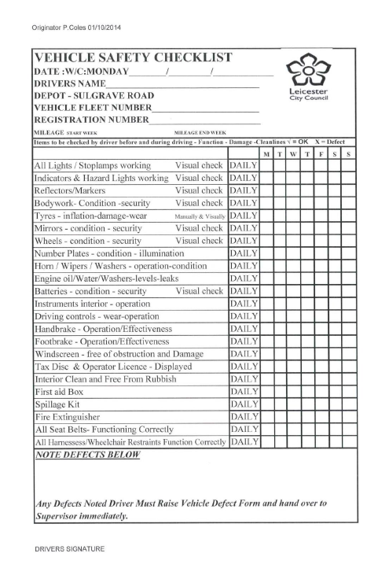
Appendix A Vehicle Checklist (for drivers/Providers)

Appendix B – Run Sheet template
Name | Address | Postcode | Car reg | Driver ref | Mon | Tues | Weds | Thurs | Fri | Sat | Sun | Comments
Passenger 1 | 5-9 Princess Rd West, Leicester | LE1 6TH | ABC 123 | 001 | x | x | x | x | x |  |  | School pick up/drop off.  Mon-Fri only
Passenger 2
Passenger 3
Passenger 4
Passenger 5
Passenger 6

Appendix C - Seating Plan Template

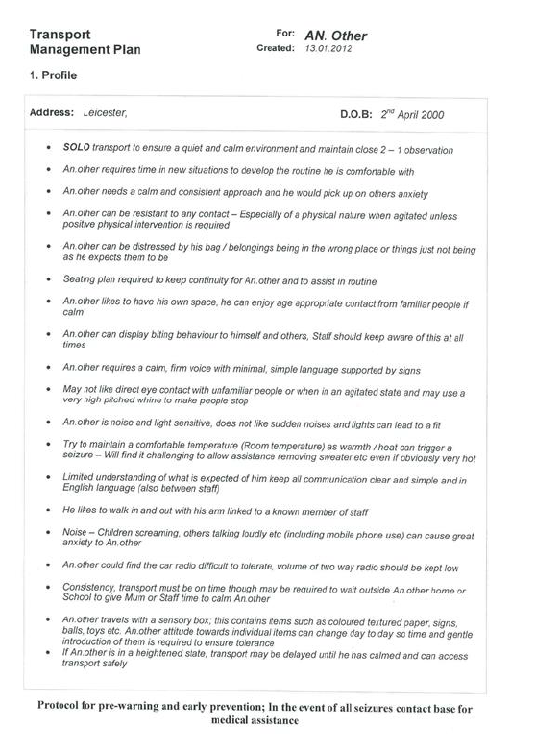
Appendix D - Example Transport Management Plan (TMP)
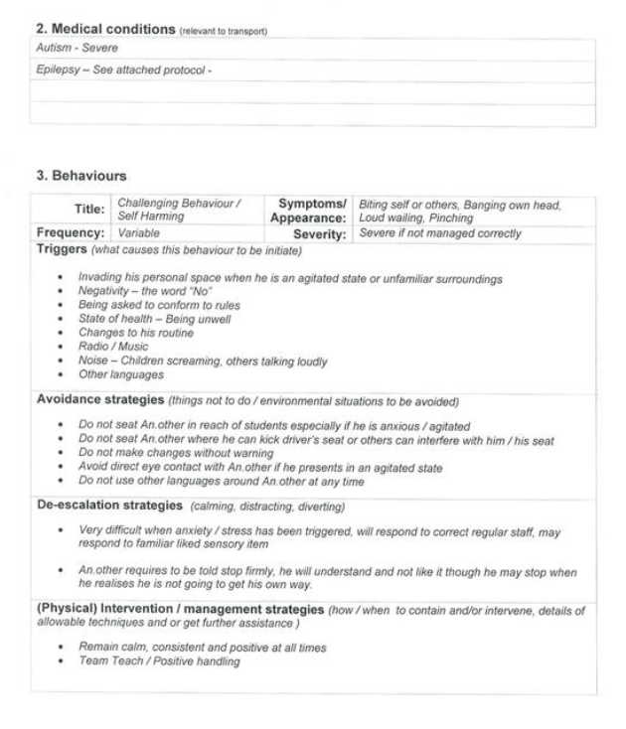

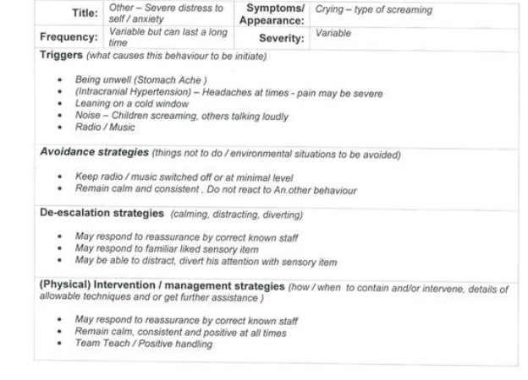
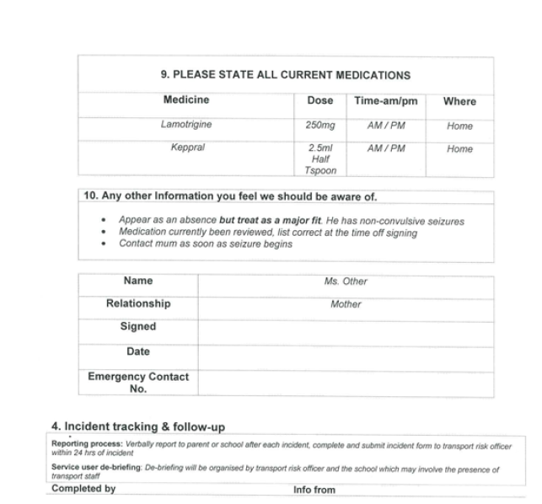

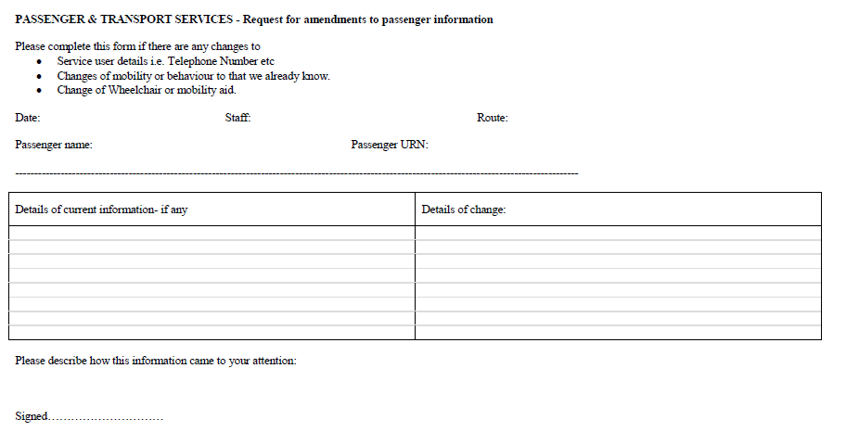
Appendix E – Service User amendment form
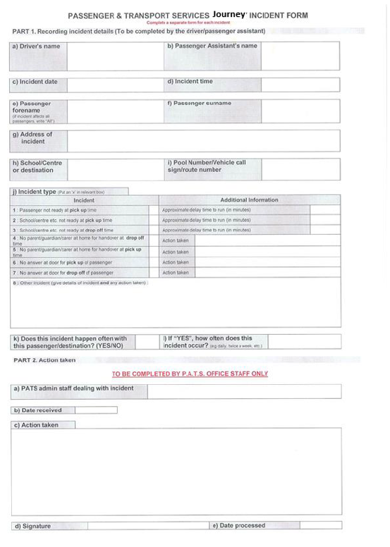
Appendix F – Journey incident form

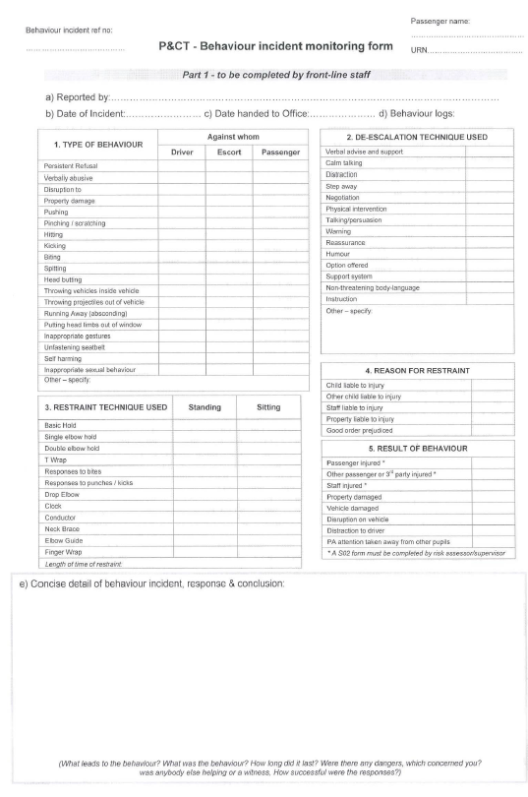
Appendix G – Behaviour Incident Form
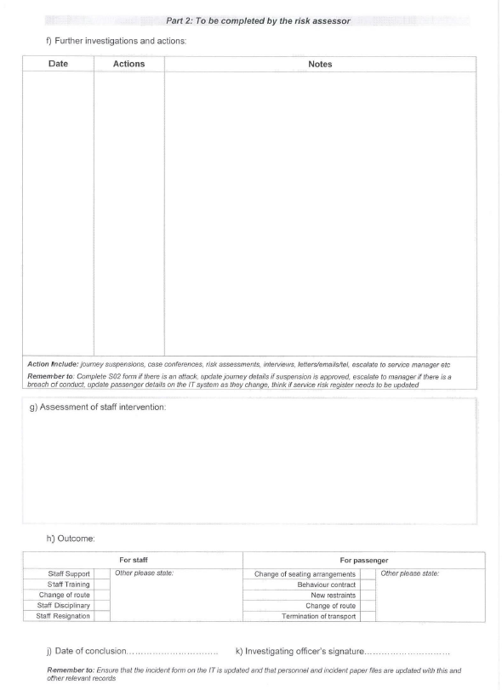

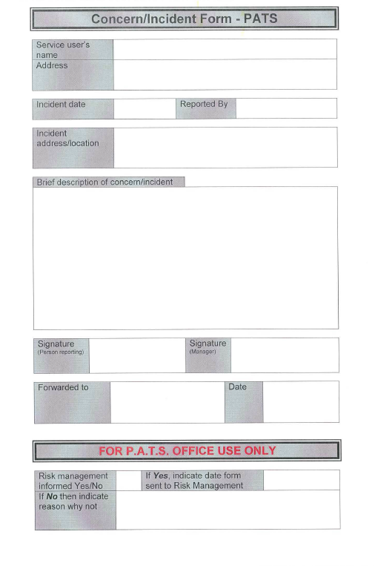
Appendix H – Concern/Incident Form
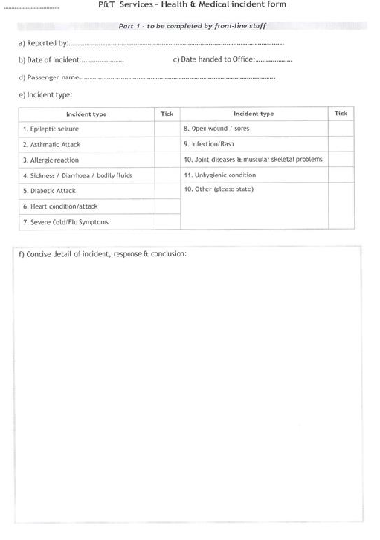
Appendix I - Medical Incident Form

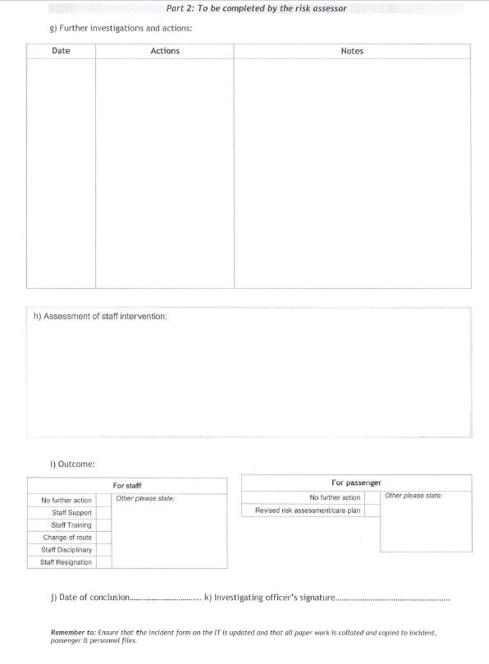

Appendix J – Motor Vehicle Claim Form
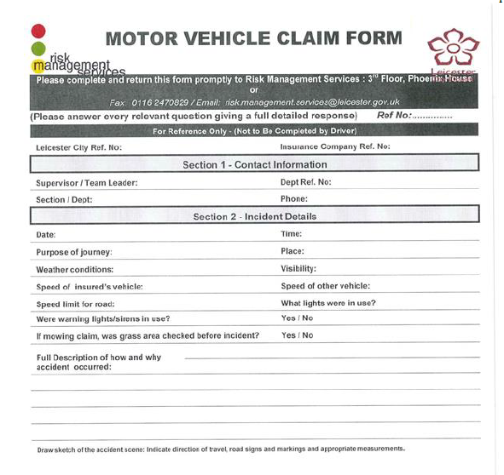

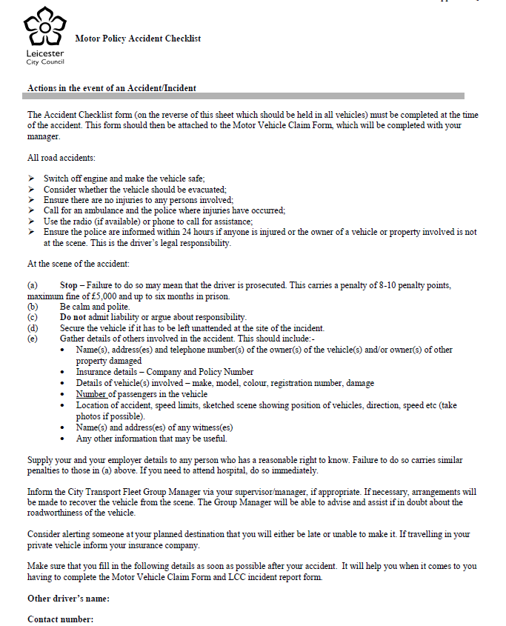
Appendix K - Accident Checklist Form

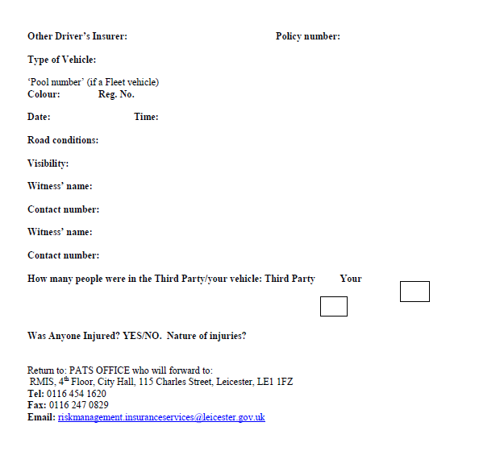

Appendix L – Pro-forma template

Appendix M – Code of Conduct for Drivers and Passenger Assistants
Code of Conduct for Drivers and Passenger Assistants - Leicester City Council Taxi Agreement
This Code of Conduct outlines some of the key behavioural requirements for Drivers and passenger assistants. It acts as a reference guide for Drivers and passenger assistants.
All Drivers and passenger assistants must sign this form prior to working on the Agreement.
Drivers and passenger assistants: | Tick to confirm
I will meet the journey requirements I have been commissioned to provide, as per the Service User’s specified needs. I will notify my Provider of any changes to this
I will wear a clearly visible ID badge issued by the licencing authority and will not share this ID badge
Wherever possible, I will support and encourage Service Users to be independent. For example, carrying their own bags or fastening their own seat belt if safe for them to do so
Where I believe that a Service User is unsafe or is at risk of abuse, I will report this in line with my safeguarding responsibilities
I will conduct myself in a professional, polite & helpful manner when working with members of the public, Service Users, parents/carers, local authority, school & contact centre staff at all times
I will not be under the influence of drugs or alcohol at any time during my work
I will manage my time effectively, being realistic in travel times and being aware of travel conditions as much as reasonably possible
Where appropriate and safe to do so, I will support Service Users with equipment (e.g. walking frame, wheelchair) to access/leave the vehicle safely
I will act within my competence level and in accordance with the training I have completed to undertake my duties
I will not leave a vulnerable Service User unattended. Where a parent/carer/school fails to meet a Service User, I will follow agreed processes to ensure the journey can be completed safely
I will support Leicester City Council staff to conduct their business and comply with spot checks
I have read and understand the requirements set out in the Agreement Specification and will fulfil my duties accordingly
Drivers only:  If you are a Driver, please also read and sign the below: | Tick to confirm
I will adjust my driving style to help Service Users to feel safe and comfortable during the journey
I will drive according to the conditions of my ‘Driver’s licence’ and ‘taxi and private hire licence’. This includes the Highway Code, Road Safety Act 2006 and all Road Safety Regulations
I will always come to a stop at a destination and make the vehicle safe before allowing Service Users to enter/leave the vehicle
I will not transport any unauthorised passengers on any journey

Signed by Driver/Passenger Assistant (delete as necessary) | Name:
Signed by Driver/Passenger Assistant (delete as necessary) | Signature:
Authorised by Council Officer | Name:
Authorised by Council Officer | Signature:

