CAPITAL PROGRAMME
BIDDING PROFORMA FOR SCHEMES STARTING 2016/17 TO 2018/19

BID REFERENCE NO: | Please leave blank
SCHEME NAME: | ICT Capital Investment: Covering Collaboration Systems
START YEAR: | X  2016/17: | 2017/18: | 2018/19  (indicative):
DEPARTMENT/DIVISION | Information Services
RESPONSIBLE OFFICER | Carl Skidmore, CIO, Information Services

1. | SCHEME DESCRIPTION:  Describe the scheme, and the reasons why it fits the bidding criteria. | Information Services have a planned capital programme of £1.6M covering this period. This spend is in three broad groupings:  - Core platform Infrastructure (£603K)  - End User Computing (£285)  - Collaboration Services (£760)  Some of the initiatives support the IT Spending Review goals. These fall within Items 1 and 2. Consequently, we intend to fund the Core platform Infrastructure and End User Computing initiatives internally using Information Services budget. Details of the proposed Capital Programme are provided in Figure 1.  This Scheme is however seeking funds to deliver improved Collaboration Services which are used across the Council as a whole. This covers three areas:  - An upgrade or replacement of our central Electronic Document Management System (EDRMS). The current system, while licenced and supported by the supplier, is now seven years old and is no longer being developed and is based on old technology.  Upgrading to or replacing our current EDRMS with a more modern web based Enterprise Content Management (ECM) would provide the opportunity for further savings as detailed in the outputs below. These would be enabled by better document collaboration tools, enabling wider access through a more intuitive user interface and mobile access. We would also reduce risk – by enabling more people to use content management and by making sense of unstructured data we open up the facilities of the EDRMS system to more people and more types of data.  More modern systems are capable of working with data stored in other systems – so rather than just being a data store the ECM can manage documents in other systems.  So, by upgrading/replacing the current EDRMS we will enable efficiency savings across the council.  Capital Revenue  2016/2017 £330K £60K  2017/2018 £60K  - An upgrade or replacement of our Automatic Call Distributor (ACD) system.  The current ACD Infrastructure has been upgraded over its lifetime without following the correct procurement process. Therefore the Council cannot demonstrate that the existing system offers value for money.  The current system consists of :  - 5 Liberty Servers  - 330 Channels of SIP  - System licence for Call Recording  - System Licence for Soft wallboards  - 300 channels of 59R Contact Centre 59R  - 4 x Automation Agents  - 4 x Virtual Operator Skills  - Email Blending  - Multimedia licence for 25 concurrent users  There is a need to ensure that the ACD integrates with the new CRM system.  The current system is certified to work with Microsoft Lync however there may be other systems that offer a higher level of integration.  Capital Revenue  2016/2017 £300K £49K  2017/2018 £49K  - An upgrade to the current Lync telephony Infrastructure and supporting network services (SIP trunks).  The current Lync Infrastructure was installed in 2011. This bid is to replace the end of life infrastructure with new hardware and SIP services.  The current server infrastructure consists of :  - 6 servers split between 2 pools. SQL Backend consisting of 6 servers. 1 OfficeWebApp server for PowerPoint presentation.  - 3 Sonus UX200 Gateways  - 2 Virgin SIP Trunks. These may be provided by another supplier and this move will generate savings.  Capital Revenue  2016/2017 £130K £40K  2017/2018 £40K

2. | FINANCIAL  ASSESSMENT (CAPITAL): | 2016/17  £000s | 2017/18  £000s | 2018/19  £000s | Later Years  £000s | TOTAL  £000s
 | Gross capital cost | 760
 | Other capital funding. Please list.
 | Net cost falling to corporate programme.

3. | FINANCIAL ASSESSMENT (REVENUE): | 2016/17  £000s | 2017/18  £000s |  | 2018/19  £000s | Later Years  £000s | Full Year  £000s
 | Direct revenue costs | 149 | 149 |  | 149 | 149
 | Direct revenue savings | EDRMS= 65  ACD= 50  Lync= 45  Total= 160 | 65  50  45 |  | 65  50  45 | 65  50  45
 | Net cost/(saving) | 16 | 16 |  | 16 | 16
4. | OUTPUTS:  What are the main outputs and outcomes from the scheme? Please list.  (Also include in this section the extent to which expenditure would facilitate future capital receipts and/or avoid future cost.) |  |  | - EDRMS replacement: Since procuring one of industry’s leading EDRMS products Open Text eDocs R/KYV in 2008, good progress has been made in deploying the system and we now have over 1,200 users. The main uses are for electronic Social Care Records, corporate complaints, property records and electronic employee file pilot in HR.  Replacing or upgrading will provide a number of enhancements as follows:  - Basic Collaboration tools - provides workspaces for projects/virtual teams to work collaboratively on projects or to produce reports. Teams could include our partners where required.  - Document and form libraries – web accessible libraries for sharing corporate documents or forms such as committee reports or policies and standards.  - Web Enabled Portal – replaces the need for a desktop client application with an easy to use and deploy portal that allows users to securely access documents and data via any internet enabled PC or mobile device. This could also facilitate partner access to documents.  - Federated Search – improved discovery tool that will search and retrieve information across multiple sources to provide relevant information.  - Business Process Management – improved workflow tools allow users to graphically create process workflows and reports to identify progress of a given document, report or request.  - Archiving - automated archiving and preservation of key records to ensure digital continuity and reduce storage costs.  This upgrade would allow us to meet the requirements outlined by the ODIB to create and maintain corporate version controlled document libraries and to make these documents available to staff via a web browser and without the need to install specialist software e.g. project documents or corporate policies and procedures. It would also provide the tools that we would need to improve the process for producing committee reports by implementing version control and a workflow process to automatically route reports to committee secretaries.  - ACD Replacement: Provision of the replacement equipment will ensure that the Council is compliant from a procurement perspective. The new solution will better integrate more fully with Microsoft Lync. The new system will further offer greater resiliency.  - Lync telephony replacement: Provision of the replacement equipment will significantly reduce the corporate risk from the failure of the Microsoft Lync system. The organisation is reliant on the availability of this system in the delivery of telephony for the Council and would suffer major resource, reputation and financial disruption in the event of equipment failure.

5. | AFFORDABILITY:
 | Is the net revenue cost (section 3 above) affordable within the department’s revenue budget? | Yes.  It is likely that all revenue costs will be cost-neutral and at least be offset by current on-going costs for the incumbent systems.
 | If not, how are the costs to be funded?

6. | RISK:  Please identify any risks in respect of:-
 | Capital cost certainty | Exact costs will be known once tender/evaluation exercise completed.
 | Revenue cost certainty | Low risk – Support and maintenance costs are anticipated to be equal or less than those currently being paid.
 | External Funding deliverability | Not reliant on external funding.
 | Operational risks | General disruption to BAU services during implementation.

7. | IMPACT IF BID IS NOT APPROVED:
 | What would be the consequence of doing nothing? | Operating expensive end-of-life systems and in the case of the ACD using a non-compliant solution.
 | What is the “do minimum” option? | Stay with current systems and manage risks.

8. | PROCUREMENT OPTIONS:
 | What other procurement options have been considered? | None

9. | QUALITATIVE ISSUES:
 | How does the scheme affect protected groups covered by the Public Sector Equality Duty? (Protected groups are listed at the end of this form). | No adverse impact.  Potentially the replacement of these systems will improve the ability of the City Council to deliver services to these groups.
 | What evidence is there of community support for the scheme? | None
 | Identify how the scheme impacts on CO₂ emissions and measures taken to minimise this. | Modern system replacement will deliver a reduction in CO2 from technology that is designed to require less resource to operate.  Replacement of EDRMS with a more user-friendly system with greater User adoption would reduce the requirement for paper documents.

10. | Responsible Officer: | I wish to submit the bid, which has the support of departmental management.
 | Signature: | A C SKDIMORE
 | Date: | 9/9/15

11. | Head of Finance | I have reviewed the financial information given above.
 | Signature:
 | Date:

[Please expand size of boxes as required]

Notes

Protected groups are those who have any of the following protected characteristics:

- Age
- Disability
- Gender re-assignment
- Pregnancy and maternity
- Race
- Religion or belief
- Sex
- Sexual orientation

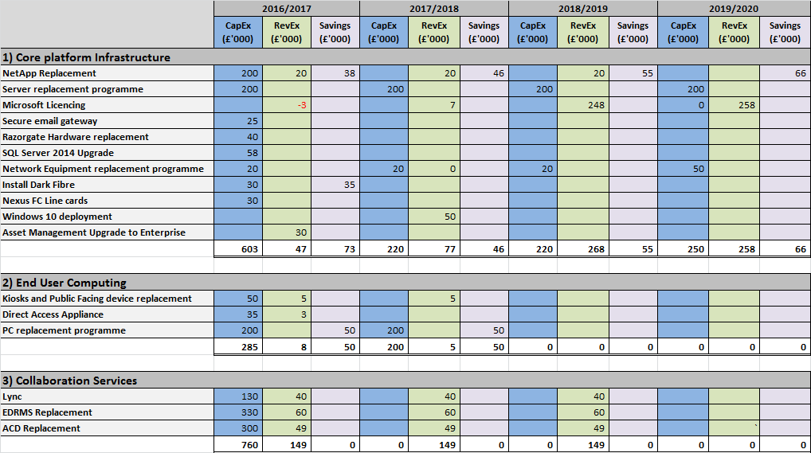
Figure 1: IS Capital Programme

