FREEDOM OF INFORMATION ACT 2000/ENVIRONMENTAL INFORMATION REGULATIONS 2004

Your request for information has now been considered and the Council’s response to your questions is shown below.

You asked:

This is a request for information under the Freedom of Information Act 2000. My request relates to council funding for social workers and care homes for children in care.

I would like to request the following information for the years 2016-17, 2017-18, and 2018-19, specifically with regards to social workers working with children in care.

- For each year, the overall funding provided for any spending related to children's social care.
- For each year, the amount of money spent by the council on public- sector social workers; that is, social workers hired directly by the Council, rather than through private-sector agencies.
- For each year, the amount of money spent by the council on private- sector social workers; that is, social workers hired through private- sector agencies, or contracts with private-sector social worker agencies generally.
- For each year, the amount of money spent by the council on public- sector children's care homes.
- For each year, the amount of money spent by the council on private- sector children's care homes.

In respect of questions 1-5, please see the table below.

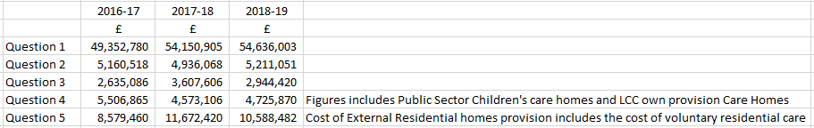

You may re-use the information under an Open Government Licence.

If you are dissatisfied with the handling of your request, please write to:

Internal Review
Information Governance & Risk Leicester City Council
City Hall, 115 Charles Street Leicester LE1 1FZ

info.requests@leicester.gov.uk

