Freedom of Information Act 2000/Environmental Information Regulations 2004
re: Stray Dog Project

Your request for information has now been considered and the Council’s response to your questions is shown below.

You asked:

We are researching the welfare and outcomes of dogs in local authority shelters (sometimes termed ‘pounds’), including euthanasia. We intend to analyse the data and include it in a scientific publication. We request the following information:

For each of the last 3 years (2021, 2022, 2023), please provide the following information:

- The number of dog places that you have available at any one time in your shelter(s) or pound(s)

Answer:

As per contract they have to be able to take a maximum of 400 dogs per year.

- The number of dogs that have spent any time in your dog shelter(s) or pound(s).

2021 - 121 dogs
2022 - 162 dogs
2023 - 171 dogs

- The number of stray dogs that have entered a shelter/pound(s)

2021 - 121 dogs
2022 - 162 dogs
2023 - 171 dogs

- The number of dogs that have entered a shelter/pound(s) that were seized for welfare reasons

N/A

- The number of dogs that have entered a shelter/pound(s) that were seized for human safety reasons

N/A

- The number of dogs that have entered a shelter/pound(s) that were relinquished

N/A

- The top 3 breeds of the dogs that entered the shelter/pound(s) plus amount of each breed

2023 top breeds.
1: 25 Staffordshire Bull Terrier
2: 21 French bulldog
3: 14 XL Bully

2022 top breeds.
1: 26 Staffordshire Bull Terrier
2: 13 French bulldog
3: 8 Chihuahua

2021 top breeds.
1: 20 Staffordshire Bull Terriers
2: 9 Spaniel and crossbreed
3: 8 Husky

- The number of dogs that were rehomed directly from your shelter

They do not directly rehome

- The number of dogs that were moved to another rehoming centre (e.g. run by a charity) in the UK/Ireland and abroad

Dogs that were transferred to other rehoming centres in the same month:
2023 - 50
2022 - 42
2021 - 21

- The average length of stay of dogs in your shelter/pound(s)

2023 - 11 days
2022 – 8 days
2021 - 5 days

- The number of each type of breed of dog that were euthanised.

2021 -
1x Malamute
1xRottweiler
1x Bullbreed

2022 -
5xSBT
1x Frenchie
1x Mastiff cross
1xChihiahua
1 Belgian Malinois

2023 -

1x Yorkshire Terrier
5x Xl Bully
1x Bull Mastiff
1x Frenchie
4x Shihtzu
2x JRT
2x Staffordshire bull terrier
1x Crossbreed
1xDacshund x SBT
1x pitbull
1x Sharpei

Currently:

- Do you have any written policies on

- Welfare of the dogs in your shelter/pound(s), including requirements for exercise, enrichment, formal behavioural assessment? Yes/ No (If yes, please provide)

We do not have Policies however the below are extracts from our contract regarding the welfare of the dogs in the shelter.

The Supplier must kennel each dog for the period specified by the Authority. Where the Authority does not specify this period, the dog must be kennelled for the statutory retention period of seven clear days from the seizure unless the dog is claimed by the owner before the expiry of that period.
The Supplier must provide suitable and adequate meals for each dog and ensure that fresh water is available at all times; individual diets must be catered for and should include proprietary dried or tinned dog meat, or fresh meat as specified in 3.2.1.
The dogs must be provided with at least two 15-minute exercise sessions a day in a secure separate exercise area, adjoining the kennel block detailed above. A record of when each individual dog is exercised must be made and retained.
All reasonable precautions must be taken to prevent and control the spread of infections or contagious diseases among the dogs. Separate isolation kennels and facilities must be provided with easily cleansed hard, impervious surfaces and must properly drain and maintain an adequate temperature for the dogs. Such kennels are to be thoroughly disinfected and cleansed before each change in occupancy.
If a dog is ill or injured at the time of receipt or becomes ill or suffers injury whilst in the care of the Supplier during the statutory retention period, the Supplier must ensure that the dog receives prompt treatment by a veterinary surgeon. Subsequent to any treatment, the Supplier must comply with any further requirements the veterinary surgeon recommends in respect of that dog. The Supplier will be liable to pay any veterinary fees incurred relating to the treatment of any dog in respect of any illness or injuries suffered whilst in the care of the Supplier. The Authority will be responsible for all other costs associated with treatment by the veterinary surgeon, however, authorisation from the Authority must be obtained prior to any treatments being undertaken where a single or overall treatment cost exceeds £100.00.

- Euthanasia of dogs in your shelter/pound(s)? Yes/ No (If yes, please provide)

Euthanasia should only be considered after all other avenues have been explored to save the dog by re-homing.

- Please provide your most recent inspection report including the recommendations for improvement

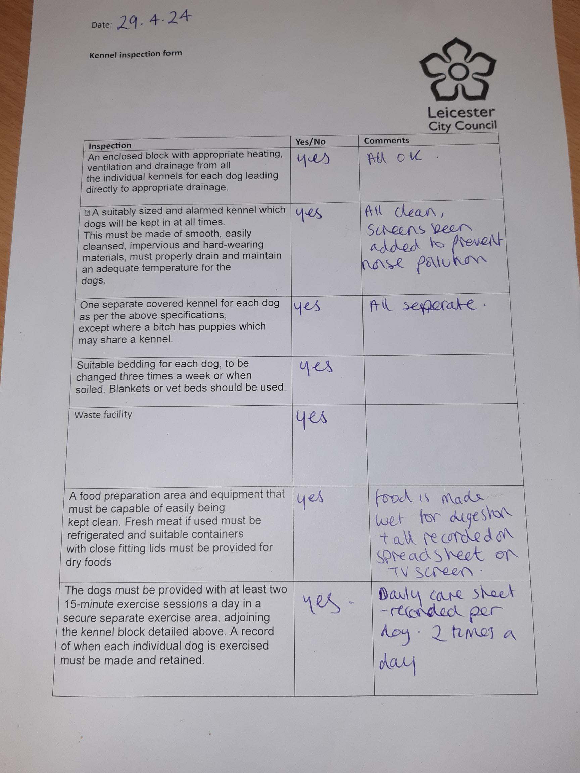

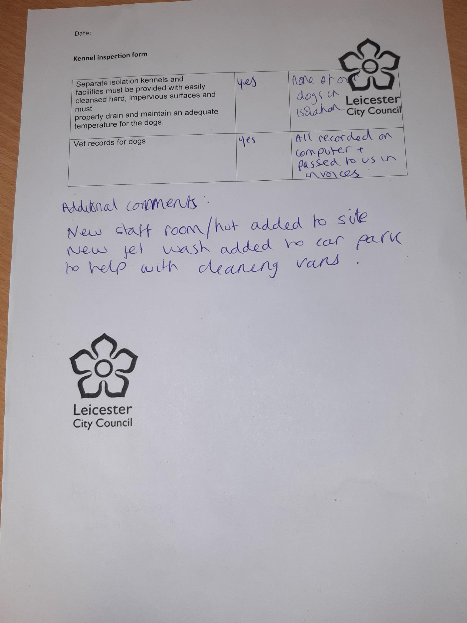

- Please provide the Full Time Equivalent staff and level of formal training of the staff that work in your shelter/pound(s)

These are not the council’s staff members, so we do not have records of the qualifications they hold. This letter therefore acts as a refusal notice under section 17.1 of the Freedom of Information Act 2000 because, in accordance with section 1.1 of the Act, this information is not held by Leicester City Council.
You may re-use the information under an Open Government Licence.

