FREEDOM OF INFORMATION ACT 2000/ENVIRONMENTAL INFORMATION REGULATIONS 2004

Your request for information has now been considered and the Council’s response to your questions is shown below.

You asked:

I am writing to you under the Freedom of Information Act 2000 to request the following information:

Can you please provide the Local Plan Policies map for the Council? Can you please provide this in shapefile (.shp) format?

Please see the 3 relevant compressed files below.

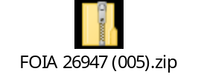
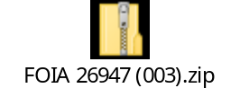
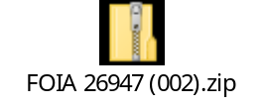
You may re-use the information under an Open Government Licence.

If you are dissatisfied with the handling of your request, please write, explaining your grounds of appeal, to:

Internal Review
Information Governance & Risk
Email: info.requests@leicester.gov.uk

