Leicester Domestic Abuse Locality Partnership Board
Terms of Reference

- Purpose and role

  - The Leicester Domestic Abuse Partnership Board (‘the Board’) is a partnership group responsible for supporting Leicester City Council in meeting its duties under Part 4 of the Domestic Abuse Act 2021 (local authority support) which include the following requirements:

    - To assess the need for accommodation-based support.

    - To prepare and publish a strategy for the provision of such support.

    - To monitor and evaluate the effectiveness of the strategy.

  - The Board will work together to support, advise, and work in partnership with Leicester City Council to ensure that victim-survivors of domestic abuse have access to adequate and appropriate support, and in particular safe accommodation, as defined in the Domestic Abuse Act 2021.

  - The Board will work together to improve outcomes for adult and child victim-survivors of domestic abuse.

- Frequency

  - The Board will meet on a quarterly basis as a minimum. The Board will determine if there is a need for more frequent meetings during key periods, such as implementation.

- Membership

  - The Board is made up of the following representatives (individual names are subject to change):

Agency | Service/Role | Representative(s)
City Council | Director of Children’s Social Care & Early Help | REDACTED
City Council | Director of Housing | REDACTED
City Council | Director of Adult Social Care & Safeguarding | REDACTED
City Council | Director of Public Health | REDACTED
Leicestershire Police | Police Strategic Partnership Officer  Serious Crime – Adult Safeguarding | REDACTED
LPT | Head of Safeguarding | REDACTED
CCG | Designated Nurse Safeguarding Adults & Children | REDACTED
UHL | Head of Safeguarding | REDACTED
LWA | Commissioned CYPFS Domestic Abuse Provider – child’s voice/DA Provider | REDACTED
Freeva | Commissioned DA Perpetrator Interventions Provider/DA Provider | REDACTED
Panahghar | Commissioned DA BME Safe Home Service Provider | REDACTED
WALL | Commissioned DA Safe Home Service Provider/DA Provider | REDACTED
Scrutiny & Reference Group (SRG) | Victim-survivor voice | REDACTED
City Council | Deputy Mayor and Lead Member for Domestic Abuse | Cllr Sarah Russell

Agency | Service/Role | Supporting officer(s)
City Council | Head of Service, Housing | REDACTED
City Council | Head of Service, Housing | REDACTED
City Council | Head of Service Children in Need, Children’s Social Care & Early Help VICE CHAIR OF DELIVERY GROUP | REDACTED
City Council | Head of Service – Prevention and Safer Communities CHAIR OF DELIVERY GROUP | REDACTED
City Council | Head of Revenues & Customer Support | REDACTED
City Council | Community Safety & Protection Service Manager | REDACTED
City Council | Domestic & Sexual Violence Team Manager | REDACTED
City Council | Domestic & Sexual Abuse Development Officer | REDACTED
City Council | Contracts Quality & Engagement officer – Scrutiny & Reference Group support | REDACTED
City Council | Legal officer to support | REDACTED

  - The Board will be chaired by Director of Children’s Social Care & Early Help.

  - The Vice Chair of the Board will be Director of Housing.

  - The Chair or Vice Chair, or their representative, will attend the Scrutiny and Reference Group (of victim-survivors) at least twice a year.

  - Up to three members of the Scrutiny and Reference Group (SRG) will attend Board meetings where possible, and SRG members will receive papers routinely via the Contracts Quality & Engagement Officer. The SRG may, if they cannot attend the meeting in person, ask that another council officer represents their feedback on their behalf.
  - Membership requests will be considered and approved by the Chair, having regard to the working size, structure, and representation of the Board.

  - Members of the Board are responsible for ensuring they report back and feed into the Board on behalf of their represented area.

- Roles and Responsibilities

  - The Board will:

    - Provide advice and data to support Leicester City Council to undertake a robust local needs assessment to identify and understand the needs of domestic abuse victim-survivors within its area (including those that present from out of area), and with specific regard to fulfilling its duties under Part 4 of the Domestic Abuse Act 2021.

    - Provide expert advice and data to support the development and delivery of a local strategy, fit for the needs of the local population, which agrees the appropriate steps needed to meet the needs identified.

    - Support Leicester City Council to effectively engage with domestic abuse victim-survivors and expert services in understanding the range and complexity of needs.

    - Amplify and advocate for the interests of child and adult victim-survivors of domestic abuse.

    - Support Leicester City Council to make commissioning and decommissioning decisions as appropriate. This can include when and how commissioning is undertaken to ensure the best and most appropriate services are made available for victim-survivors.

    - Support in ensuring join up across other related areas such as (but not limited to) housing, health, early years and childhood support, social services, and police and crime services.

    - Advise and support in dealing with issues raised and identified from engagement through both formal and informal routes.

    - Provide advice to Leicester City Council about the provision of other local authority domestic abuse support (not safe accommodation focussed).

    - Escalate issues, via an agreed representative, to other relevant partnership or single agency structures as appropriate.

    - Manage potential conflicts of interest appropriately.
- Agendas and secretariat functions

  - The Board will be supported by the Domestic and Sexual Violence team at Leicester City Council. Papers will be circulated at least a week prior to meetings and draft minutes will be circulated within a fortnight of the meeting taking place.

  - The Board meetings will be audio recorded for the purposes of producing the minutes and these recordings will be destroyed following acceptance of the draft minutes as accurate. Minutes will be retained in line with council policy for a period of seven years.

  - The Board will operate open and closed sections of business, with commissioning discussions (not appropriate for providers to be present) taking place during the closed section of business.

  - Members will be able to put forward suggested agenda items for consideration to the Chair of the Board.

  - Standing agenda items will include:

    - Minutes/actions
    - Needs assessment/performance data
    - Delivery plan
    - Scrutiny and Reference Group
    - Commissioning/finance
    - Service developments
    - Emerging issues relevant to the duty
    - Reporting to/from

- Absence

  - Where members are unable to attend a meeting, they are responsible for informing the Board ahead of the meeting and, as far as possible, should ensure a representative is present on behalf of their organisation/body and that they have been sufficiently briefed on current business and outstanding actions.

- Reporting

  - The Chair, on behalf of the Board, will report up to the Senior Management Team of Leicester City Council at least twice a year and the relevant scrutiny commissions at least once a year.

  - The Board will report issues as relevant to the Leicester, Leicestershire & Rutland Adult Offending and Vulnerability Sub-Board of the Strategic Partnership Board.

  - The Board will support Leicester City Council in reporting back to the Department for Levelling Up, Housing and Communities (DLUHC) on delivering the duty in line with statutory guidance and the standardised reporting form through production of an annual report.

- Governance

  - Diagram of governance and reporting lines:

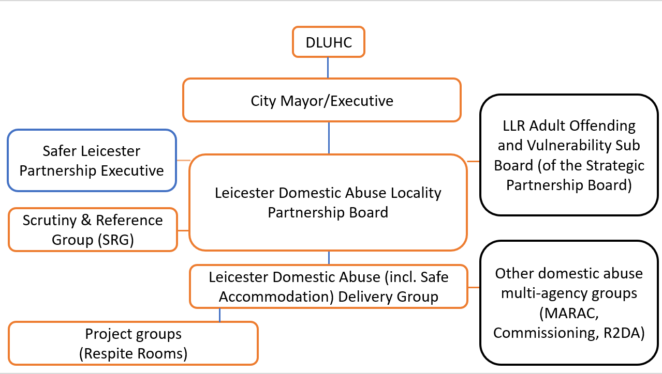

Version | 1.1
Date signed off: | 3/3/23
To be reviewed: | March 2024
Further reviews: | Every 12 months

