FREEDOM OF INFORMATION ACT 2000/ENVIRONMENTAL INFORMATION REGULATIONS 2004

Your request for information has now been considered and the Council’s response to your questions is shown below.

You asked:

Please can I request the current rates for Domicialiary/Homecare care supply; both framework and out of framework rates. This should be for care staffing supply across all ages; children, young people and adults.
Framework Rates:

LOT1 (Generic Domiciliary Care): 2024/2025

Rates | Day Support / Waking Night Rate (per hour) | Sleeping-In Rate  (per night) | Live-In Rate  (per week)
Average Rate | £21.50 | £144.86 | £1,430.44
Highest Rate | £21.95 | £186.83 | £1,720.87
Lowest Rate | £20.87 | £121.75 | £1,215.87

LOT2 (Complex Domiciliary Care):

Rates | Day Support / Waking Night Rate (per hour) | Sleeping-In Rate  (per night) | Live-In Rate  (per week)
Average Rate | £22.09 | £150.42 | £1,477.09
Highest Rate | £22.75 | £194.26 | £1,605.82
Lowest Rate | £20.87 | £121.75 | £1,215.87

Out of Framework Rates:

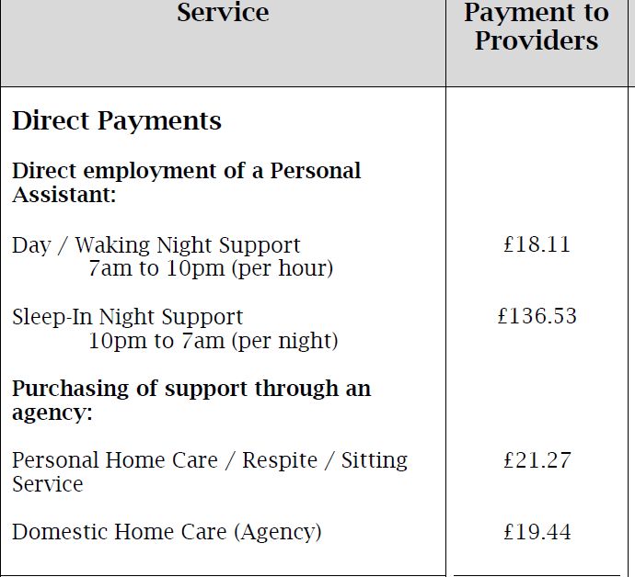

Children’s social care do not have a framework, instead they use the Direct Payment rates (out of framework rates above) for all domiciliary/ home care provision.
It would also be helpful if you could let us know the right point of contact regarding Homecare supply engagements (Tendering or spot purchase) . This could be supplier engagement officer, commisioning support team, etc. Please include:
Name of the officer in charge, Email, Phone Number

Michelle Larke, Head of Commissioning| 0116 454 1781 | Michelle.Larke@leicester.gov.uk

You may re-use the information under an Open Government Licence.

