**Journey Time Data**

This is taken from our Floow speed data which we monitor each year during Sept/October – please see below maps for the past 4 years (not 2020 due to Covid).

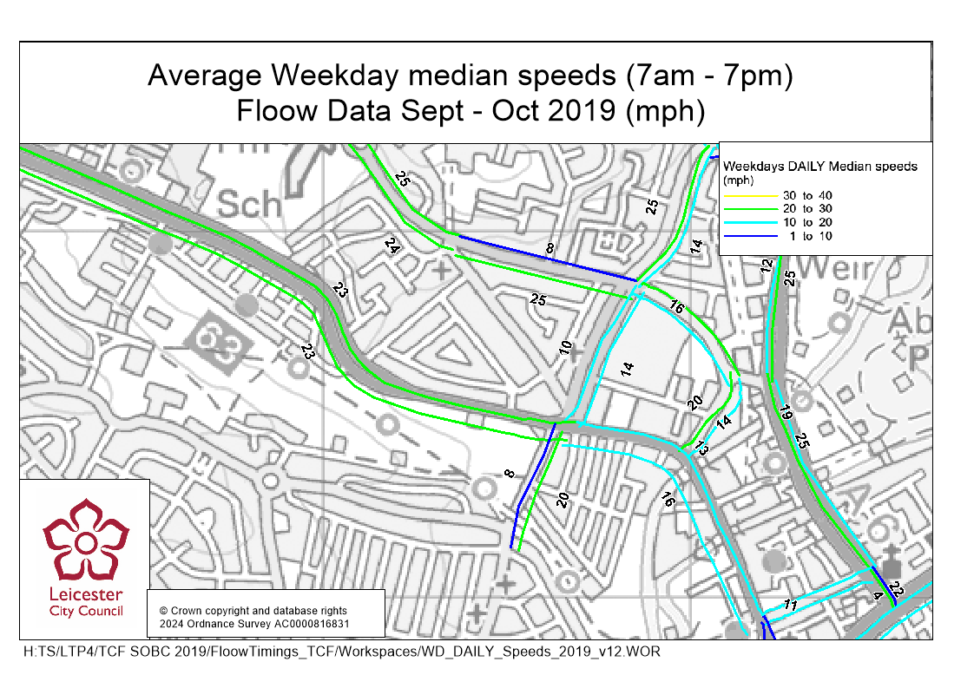

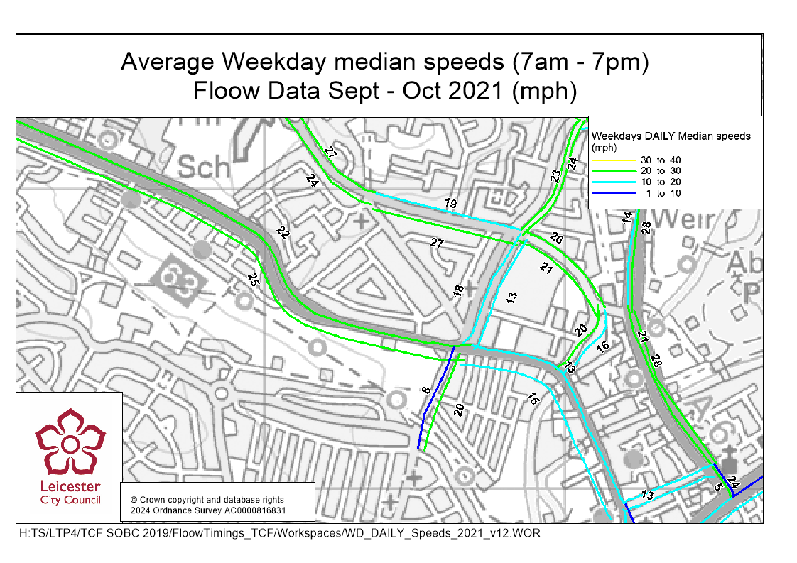

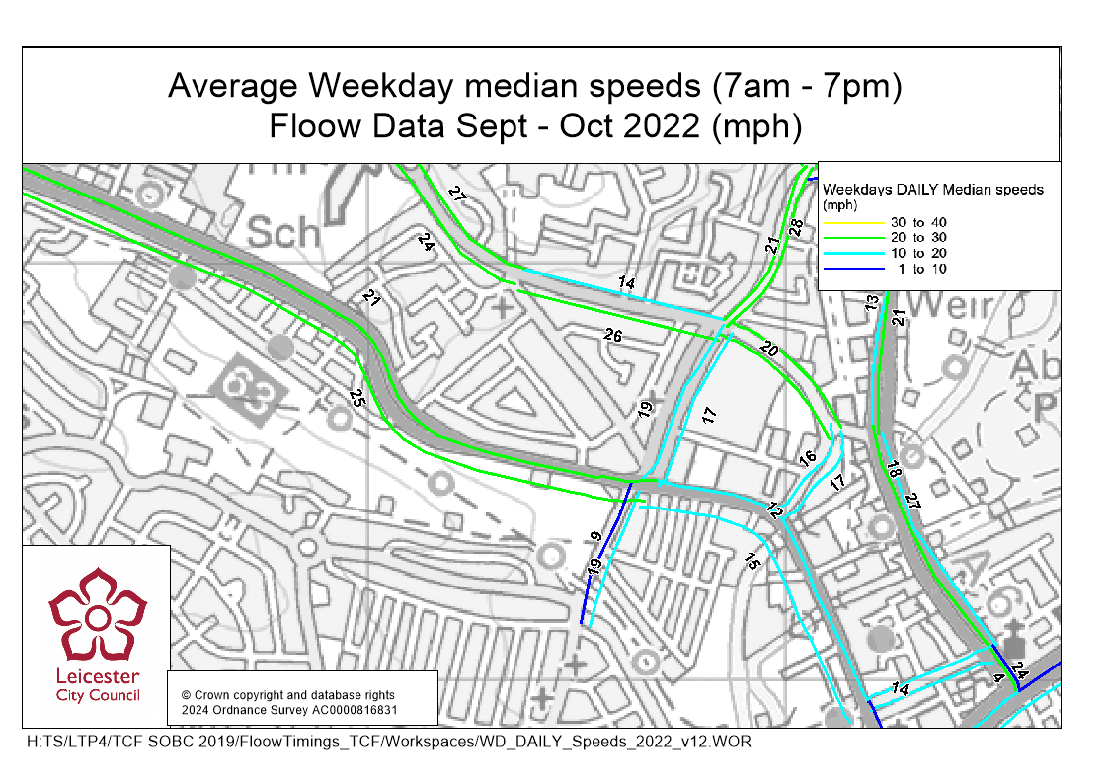

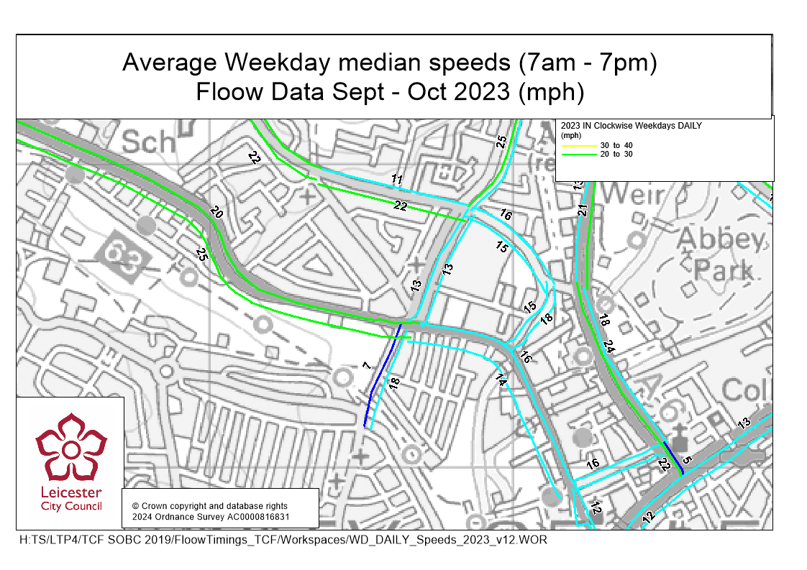

**Pollution Data**

**Note the statutory guideline target for air quality is less than 40 ug/m3**

We have an air quality monitor located at the Blackbird Road/Anstey Lane/Ravensbridge Drive junction which has given us the below information:

Until 2022, we also had Diffusion Tube monitors located at various points around the city, the most relevant of these to the TCF A50 scheme are located on Groby Road close to Brading Road and on Woodgate close to Slater Street.

For 2022, the Groby Road monitor had an annual average NO2 level of 28.4ug/m3 and the Woodgate monitor had an annual average NO2 level of 27.7ug/m3 (With a Time Weighted Average of 33ug/m3, which was calculated due to 'an exposure period exceeding the recommended five-week period on one or more occasions'). All info is publicly available in the LCC ASR 2023 on the council's Air Quality webpage - [Air quality (leicester.gov.uk)](https://www.leicester.gov.uk/your-council/policies-plans-and-strategies/environment-and-sustainability/air-quality/).

Unfortunately, we currently don't have our diffusion tube network monitoring, however we hope to have it up and running again for 2025.