Freedom of Information Act 2000/Environmental Information Regulations 2004
re: water abstractions

Your request for information has now been considered and the Council’s response to your questions is shown below.

You asked:

We were looking for any private water abstraction for 1km search radius of our Site boundary.
A small part of the Site to the west falls under Oadby and Wigston Borough Council.

You could please confirm if any abstractions are present for that area (Address: LONDON ROAD LEICESTER, Leicestershire, LE23JW) ?
Attaching the map for your reference.

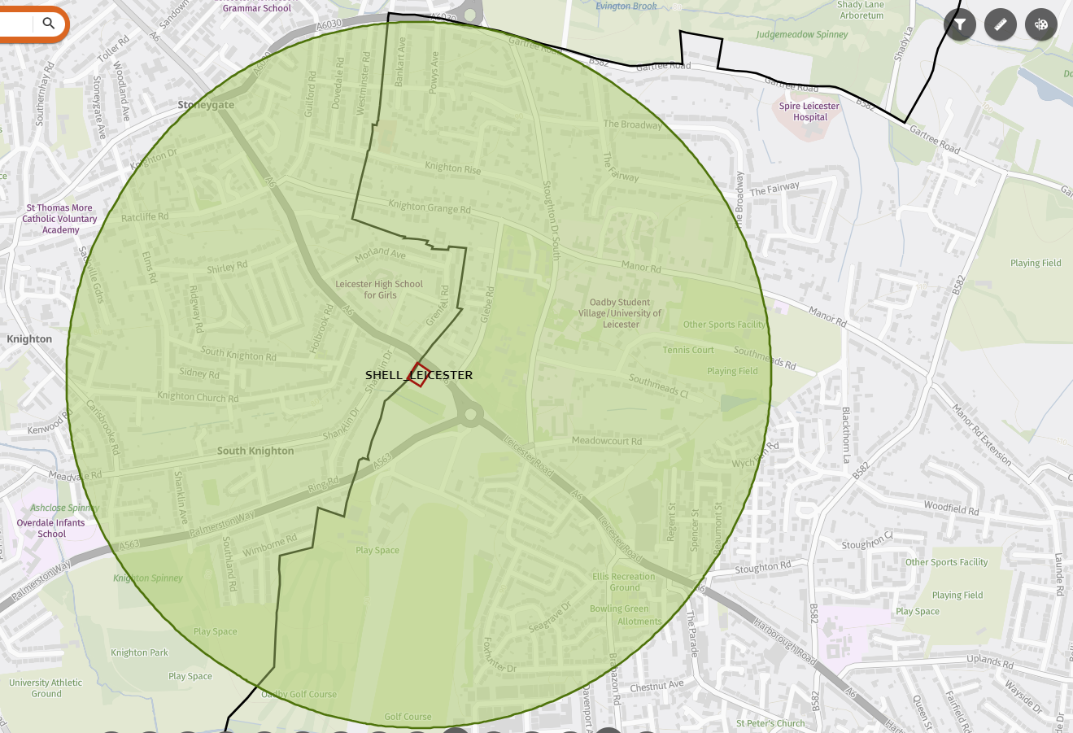
Answer:

There are no known water abstractions within 1km of Shell, Trocadero. The other sites are not located within Leicester City Council’s area and therefore that is information not held and the Council is informing you as required by Section 1(1) of the FOI Act and Regulation 12(4)(a) of the EIR.

We would advise that you contact Leicestershire County Council on foi@leics.gov.uk

You may re-use the information under an Open Government Licence.

If you are dissatisfied with the handling of your request, please write, explaining your grounds of appeal, to:

Internal Review
Information Governance & Risk
Email: info.requests@leicester.gov.uk
.

