FREEDOM OF INFORMATION ACT 2000/ENVIRONMENTAL INFORMATION REGULATIONS 2004

Your request for information has now been considered and the Council’s response to your questions is shown below.

You asked:

I am writing to you under the Freedom of Information Act 2000 to request the following information, regarding the delivery of Family Therapy services:
1. What Family Therapy services do you currently commission/deliver (e.g. FFT, FFT-CW, MST)?

Leicester Family Therapies service currently deliver:
Multisystemic Therapy (MST), Multisystemic Therapy – Child Abuse and Neglect (MST CAN), and Functional Family Therapy – Child Welfare (FFT-CW)
2. Can you please provide a copy of the current contract award notice?

All of our family therapy teams deliver their respective programmes in house and therapists are LCC staff members.
3. What is your annual budget for this service?

£2.4m across all teams.
4. When does your current commissioning contract end? (month/year)

Our contract is on-going.
5. How many families utilise the intervention in the last 12 and 24 months?

In the last 12 months: 136 families (251 children)
In the last 24 months 270 (477 children)

6. What are the KPI's measured?

Monthly targets:
- 90% of families reporting that the MST therapist is adherent to the model
- Average adherence score of MST Therapists adhering to the MST model (0.61 benchmark)
- FFT Families reporting improvement of + 1 point within the first phase of treatment
- Number of Therapists caseloads which remain in line with research on best outcomes - MST: 5 cases per Tx
- Number of Therapists caseloads which remain in line with research on best outcomes - MST CAN: 3.5 cases per Tx
- Number of Therapists caseloads which remain in line with research on best outcomes - FFT: 8 cases per Tx
- Average time in days between referral and start of treatment (target
Quarterly targets:
- % of MST and FFT: Children living at home at: Close of treatment
- % of MST and FFT: Children living at home at: 6 months post closure
- % of MST and FFT: Children living at home at: 12 months post closure
- % of MST and FFT: Children living at home at: 18 months post closure
7. What has been the performance over the last 12 and 24 months?

Family therapies measure performance in multiple areas, however the most critical measure is children remaining at home. In the year ending 31st March this figure was 90% remaining at home at the end of treatment. The target annually is 80%. The year prior was 81%. We track data for 24 months.
8. What is the referral criteria for the service?

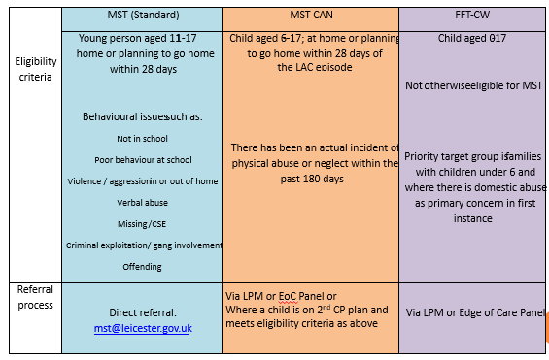
9. What is the average cost per family of the intervention?

This differs for each programme.
FFT: £10,945 per family (£10,945 per child)
MST: £12,000 per family (£5,085 per child)
MSTCAN: £29,000 per family (£8,500 per child)

10. How many children have been reunified from the care of the local authority to their families, in the last 12 and 24 months?

450.
11. What contributions have the family therapy services had toward reunification efforts?

88 of 450 children have had Family therapies intervention. 3 out of 88 are currently open to the service.

You may re-use the information under an Open Government Licence.

