Freedom of Information Act 2000/Environmental Information Regulations 2004
re: planning application refunds

Your request for information has now been considered and the Council’s response to your questions is shown below.

You asked:

Under the Freedom of Information Act 2000, I am writing to request information regarding planning application refunds within your council jurisdiction.

Please provide a list (in Excel format) of all planning applications submitted from 6th December 2023 to the most recent data available where no decision was made within the statutory period (26 weeks for major applications and 16 weeks for non-major applications), unless a longer period has/had been agreed in writing between the applicant and the Local Authority, and no refund of fees has been made to date.

Requested Columns:

- Planning application reference
- Applicant name
- Site address
- Valid date
- Planning application fee paid (£)
- Decision due date
- Actual decision date
- No. of days to decision
- The decision (e.g., approved, refused, etc.)
- Extension of time/Planning performance agreement (Yes or No)
- Refund (Yes or No)
- Eligible for Refund (Yes or No) (Based on statutory decision deadlines: 16 weeks for non-major applications and 26 weeks for major applications)
- Withdrawn (Yes or No)
- Proposal description

Please provide the information in chronological (date) order.

Answer:

The information you seek is largely published and available online on our Planning Database. The only information you seek which is not readily available online is whether or not a refund has been paid. To check this manually would exceed the time limit of 18 hours as prescribed in the Act. Whilst not definitive, we are not aware of any refunds having been made.

The applicant’s name will always be available on the application form. We cannot disclose their contact details, as it is exempt under Section 40(2) of the FOI Act –personal information.

To use our Planning Database please use this link: https://planning.leicester.gov.uk/

You can use a ‘Quick’ or ‘Advanced’ search:

The advanced search has a facility by which you can search validation dates and decision dates. It also has “development type” as a search criteria.

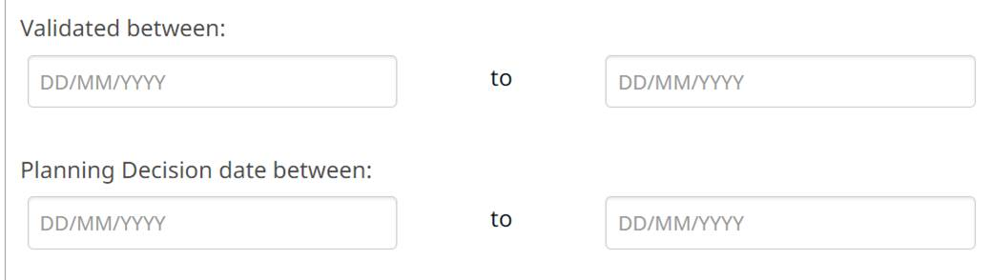

The applications will show the dates you are looking for.

“application valid date” is the date that the determination period commences
“Target Decision date” will show the date that the application is due to be determined. Where an extension of time has been agreed (as in the example below) this target decision date will change to show the agreed extension of time
“Decision date” will show the date of the decision. If the application has been withdrawn the date it is withdrawn will also show here.

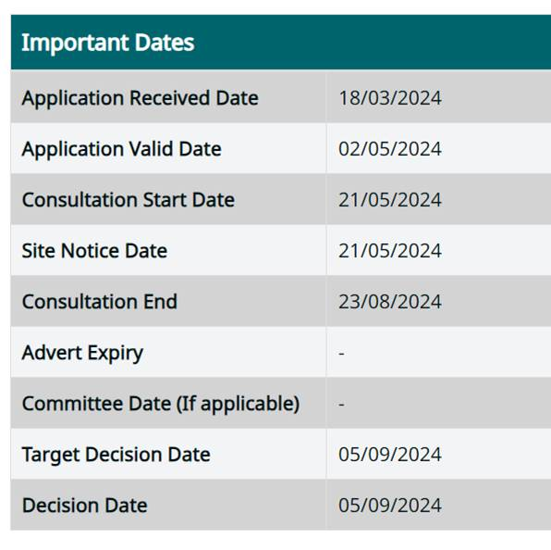

You may re-use the information under an Open Government Licence.

